Wrexham Glyndwr University’s 2020/21 Gender Pay Gap Report
The University’s commitment to equality, diversity and inclusion is a central thread in the University Strategy and within our Strategic Equality Plan 20-24 one of the two identified key Equality Objectives is to provide an inclusive approach to recruitment, progression and the employee lifecycle that promotes equality, diversity and inclusion, enabling our staff to develop and prosper in an environment where they feel treated with dignity and respect. The gender pay gap is one area we are keen to monitor, evaluate any identified differences and develop an action plan to address as necessary with the specific action plan ‘to address gender, ethnicity and disability pay differences, occupational segregation and employment gaps’.
The annual action plan will be reviewed and monitored by the Equality & Diversity Action Group, with an annual report on progress made; provided to the University’s Board of Governors and appropriate committees.
Regulations make it mandatory for all organisations with more than 250 employees to report their gender pay gap on an annual basis. Universities, along with other public sector bodies, are required to report their gender pay gap based on data on 5th April each year. The gender pay gap measures differences in pay between men and women across the entire workforce, which includes jobs of different sizes and levels. This report provides the outcomes of our mandatory gender pay gap reporting requirements and is based on 2020 data

Hourly Pay Gap
At the University, women earn £1 for every £1 that men earn when comparing median hourly pay. Their median hourly pay is 0% lower than men’s.
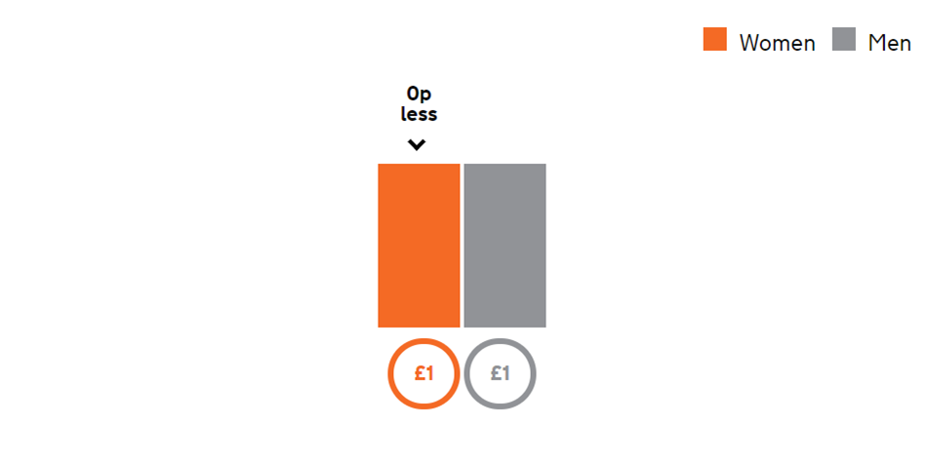
When comparing mean (average) hourly pay, women’s mean hourly pay is 7.5% lower than men’s.

The percentage of women in each pay quarter
At the University, women occupy 57.1% of the highest paid jobs and 67.5% of the lowest-paid jobs.
