Adolygiad Ymchwil 8/19
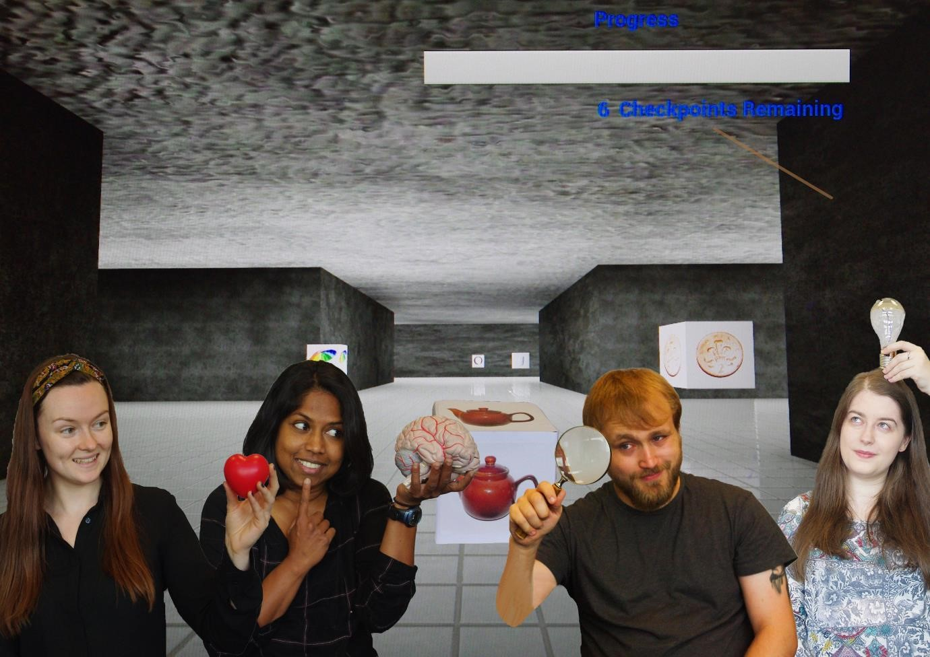

Allbynnau Ymchwil

Adolygiad Ymchwil: Allbynnau Ymchwil 2018/19

Cyflwyniad
Bwriedir i waith ymchwil Prifysgol Glyndŵr gyfrannu at ddatblygiad economaidd, cymdeithasol a diwylliannol. P’un ai yw’n ymchwil lleol neu ryngwladol, ar raddfa fechan neu raddfa fawr, mae’r pwyslais bob amser ar ddatrys problemau a gwneud cyfraniadau i anghenion go iawn.
Mae’r adroddiad hwn yn rhoi syniad o’r ystod eang o waith ymchwil a gweithgareddau cysylltiedig a wneir gan staff y Brifysgol.
Mae’r adroddiad hwn yn darparu manylion ymchwil am waith ymchwil a gwblhawyd gan fyfyrwyr, a grantiau a chontractau ymchwil ffurfiol a oedd yn weithredol yn 2018/19 hefyd.
Os hoffech gael rhagor o wybodaeth am y gwaith ymchwil a wneir ym Mhrifysgol Glyndŵr, edrychwch Yma neu ffoniwch y swyddfa Gwasanaethau Ymchwil ar 01978 293573.
Cewch weld ein storfa ar-lein o gynnyrch ymchwil yn Ymchwil Ar-lein Prifysgol Glyndŵr
Mae’r adnodd hwn yn rhoi mynediad am ddim i allbynnau’r gwaith ymchwil ac ysgoloriaethau gan staff academaidd ac ymchwil y Brifysgol, lle nad yw hynny wedi’i atal gan gyfyngiadau hawlfraint. Mae’r Brifysgol yn annog sefydliadau allanol ac unigolion i ddefnyddio ei chanlyniadau ymchwil ac i gydweithio gyda’i hymdrechion ymchwil.
Stewart Milne
Pennaeth Gwasanaethau Ymchwil

Erthyglau Cyfnodolion
Akinsolu, M. O., Liu, B., Grout, V., Lazaridis, P. I., Mognaschi, M. E. and Di Barba, P. (2019), ‘A Parallel Surrogate Model Assisted Evolutionary Algorithm for Electromagnetic Design Optimization’, IEEE Transactions on Emerging Topics in Computational Intelligence, Vol.3, No.2, pp.93-105, 2019. doi: 10.1109/TETCI.2018.2864747
Anuchin, A., Zharkov, A., Shpak, D., Aliamkin, D., and Vagapov, Y. (2019), ‘Current derivative measurement using closed-loop Hall-effect current sensor’, The Journal of Engineering, Vol.2019, No.17, pp.4027-4030, doi: 10.1049/joe.2018.8101
Grout, V. (2018), 'No More Privacy Any More?', Information, Vol.10, No.1. Available online 09 January 2019. doi:10.3390/info10010019
Hansen, M., Fyall, A., Spyriadis, T., Rogers, D. and Brander‐Brown, J. (2019), 'Motivating stakeholder collaboration within the aerial adventure industry', International Journal of Tourism Research, Vol.21, No.3, pp.311-322. doi: 10.1002/jtr.2262
Harding, C., Liggett, S. and Lochrie, M (2019), ‘Digital Engagement in a Contemporary Art Gallery: Transforming Audiences’, Arts 2019, Vol.8, No.3, 90. doi: 10.3390/arts8030090
Hu, B., Han, L., Kong, H., Nishinari, K., Phillips, G.O., Yang, J. and Fang, Y. (2018) 'Preparation and emulsifying properties of trace elements fortified gum arabic', Food Hydrocolloids, Vol.88, pp.43-49. doi: 10.1016/j.foodhyd.2018.09.027
Gao, Z., Huang, Y., Hu, B., Zhang, K., Xu, X., Fang, Y., Nishinari, K., Phillips, G.O. and Yang, J. (2019), ‘Interfacial and Emulsifying Properties of the Electrostatic Complex of β-Lactoglobulin Fibril and Gum
Arabic (Acacia Seyal)’, Colloids and Surfaces A: Physicochemical and Engineering Aspects., Vol.562, 5 February 2019, pp.107. doi: https://doi.org/10.1016/j.colsurfa.2018.11.007
Hinfelaar, M. and Hildreth, P. (2019), ‘The role of universities in peripheral regions: the case of the North Wales and Mersey Dee area’, Policy Reviews in Higher Education, Vol.3, No.2, pp.189-207. doi: 10.1080/23322969.2019.1640634
Komenda, T., Komenda, N., and Vagapov, Y. (2019), ‘Criteria of morphometric analysis of a daily load profile', International Transactions on Electrical Energy Systems, Vol.29, No.5, article e2847, doi: 10.1002/2050-7038.2847
Liggett, S. and Corcoran, M. (2018), 'Interdisciplinary Research Unmasked: a new curatorial model for multi-audience engagement', Studies in Visual Arts and Communication: An International Journal, Vol.5, No.1. Available at: http://journalonarts.org/previous-issues/vol-5-1-june-2018/
Liu, B., Akinsolu, M.O., Ali, N. and Abd-Alhameed, R. (2019), ‘Efficient Global Optimisation of Microwave Antennas Based on a Parallel Surrogate Model-assisted Evolutionary Algorithm’, IET Microwaves, Antennas & Propagation, Vol.13, No.2, pp.93-105. doi: 10.1049/iet-map.2018.5009
Livingston, W., Madoc-Jones, I.M. and Perkins, A (2019), ‘The potential of Contribution Analysis to alcohol and drug policy strategy evaluation: an applied example from Wales’, Drugs: Education, Prevention & Policy. Available online 30 Jul 2019. doi: 10.1080/09687637.2019.1645093
Mistry, K.K., Lazaridis, P. I., Zaharis, Z. D., Akinsolu, M. O., Liu, B., Xenos, T. D., Glover, I. A. and Prasad, R. (2019), ‘Time and Frequency Domain Simulation, Measurement and Optimization of LogPeriodic Antennas’, Wireless Personal Communications, Vol.7, No.2, pp.1-13. doi: 10.1007/s11277019-06299-w
Saranya, K.S., Padil, V.V.T., Senan, C., Pilankatta, R., Saranya, K., George, B., Waclawek, S and Cernik, M (2018), ‘Green Synthesis of High Temperature Stable Anatase Titanium Dioxide Nanoparticles
Using Gum Kondagogu: Characterization and Solar Driven Photocatalytic Degradation of Organic Dye’, Nanomaterials, Vol.8, No.12, available online 04 December 2018. doi: 10.3390/nano8121002 Singh, N.N., Lancioni, G.E., Medvedev, O.N., Sreenivas, S., Myers, R.E. and Hwang, Y. (2018), ‘Meditation on the Soles of the Feet Practice Provides Some Control of Aggression for Individuals with Alzheimer’s Disease’, Mindfulness, Vol.10, No.7, pp.1232-1242. doi: 10.1007/s12671-018-10750
Taylor, C. (2019), ‘From learning without limits to leading without limits: An autobiographical reflective case study of leading academic development within higher education’, Innovations in Education and Teaching International, Vol.56, No.6, available online 18 March 2019. doi: 10.1080/14703297.2019.1593212

Cyflwyniadau Cynhadledd a Phapurau mewn Trafodion Cynhadledd
Liggett, S. and Jones, M. (2018), 'The potential of painting: unlocking Disenfranchised Grief for people living with dementia'. In: Proc 1st European Association for Health Information and Libraries (EAHIL) Conference, 9-13 July 2018, Cardiff, UK, pp 38. Available at: https://eahilcardiff2018.wordpress.com/
Anuchin, A., Aliamkin, D., Shpak, D., Zharkov, A., Surnin, D. and Vagapov, Y. (2018), ‘Direct measurement of current derivative using a delta-sigma modulator for Sensorless Traction Motor Control’. In: Proc. 5th IEEE International Conference on Electrical Systems for Aircraft, Railway, Ship
Propulsion and Road Vehicles and International Transportation Electrification Conference (ESARSITEC), Nottingham, UK, 7-9 November 2018, pp. 1-4
Anuchin, A., Shpak, D., Gulyaeva, M., Aliamkin, D., Zharkov, A., and Vagapov, Y. (2018), 'A PWM Strategy for the Minimisation of Losses in a 3-level T-type Voltage Source Inverter'. In: Proc. IEEE Int. Symp. on Power Electronics, Electrical Drives, Automation and Motion (SPEEDAM), Amalfi, Italy, 2022 June 2018, pp. 703-708. doi: 10.1109/SPEEDAM.2018.8445367
Bolam, R., Vagapov, Y. and Anuchin, A. (2018), ‘Review of electrically powered propulsion for aircraft’. In: Proc. 53rd IEEE Int. Universities Power Engineering Conference UPEC-2018, Glasgow, UK, 4-7 September 2018, pp. 1-6. doi: 10.1109/UPEC.2018.8541945
Cunningham, S., Weinel, J and Picking, R (2018), 'High-Level Analysis of Audio Features for Identifying Emotional Valence in Human Singing'. In: Proc Audio Mostly 2018 (AM'18), 12-14 Sept 2018, Wrexham Glyndŵr University, UK, article no. 37. doi: 10.1145/3243274.3243313
Davies, L., Bolam, R., Vagapov, Y. and Anuchin, A. (2018), ‘Review of unmanned aircraft system technologies to enable beyond visual line of sight (BVLOS) operations’. In: Proc. 10th International
Conference on Electrical Power Drive Systems (ICEPDS 2018), Novocherkassk, Russia, 3-6 October 2018, pp.1-6. doi: 10.1109/ICEPDS.2018.8571665
Harding, C., Liggett, S., Gradinar, A and Lochrie, M (2019), ‘What Do Audiences Want from a Public Art Gallery in the Digital Age?’ In: Proceedings for EVA (Electronic Visualisation and the Arts) London, 8th – 11th July 2019, pp.137-143. Available Yma.
Klarmann, S., Vagapov, Y. and Gotzig, H. (2018), ‘Modelling and thermal analysis of advanced insulating layer electronic applications’. In: Proc. 24th Int. Workshop on Thermal Investigations of ICs and Systems THERMINIC-2018, Stockholm, Sweden, 26-28 September 2018, pp. 1-4
Kochneva, M. and Romanova, E. (2019), ‘Assessment of engineering mathematics in the context of distance learning’. In: Proc. IEEE Conference of Russian Young Researchers in Electrical and Electronic Engineering (EIConRus), Moscow, Russia, 28-31 January 2019, pp. 1902-1907. doi: 10.1109/EIConRus.2019.8656767
Kulmanov, V., Anuchin, A., Ostrirov, V., Rusakov, A. and Vagapov, Y. (2018), ‘Simulation and testing of a power converter for aircraft AC electric power generation system using software elimination of higher harmonics’. In: Proc. 53rd IEEE Int. Universities Power Engineering Conference UPEC-2018, Glasgow, UK, 4-7 September 2018, pp. 1-6. doi: 10.1109/UPEC.2018.8541922
McClanahan, C., Bolam, R., Vagapov, Y. and Anuchin, A. (2019), ‘Analysis of the effects on the pitching, rolling and yawing rate of a v-tail configured quadcopter’. In: Proc. 25th Int. Workshop on Electric Drives: Optimization in Control of Electric Drives, Moscow, Russia, 30 January – 2 February 2019, pp. 1-7
Nicholls, S., Cunningham, S. and Picking, R (2018), ‘Collaborative Artificial Intelligence in Music Production’. In: Proc Audio Mostly 2018 (AM'18), 12-14 Sept 2018, article no. 33. doi: 10.1145/3243274.3243311 8
Owens, S. and Cunningham, S (2018), 'Auditory masking and the Precedence Effect in Studies of Musical Timekeeping'. In: Proc Audio Mostly 2018: Sound in Immersion and Emotion (AM’18). ACM, New York, NY, USA, 4 pages. https://doi.org/10.1145/3243274.3243312
Veligorskyi, O., Chakirov, R., Khomenko, M. and Vagapov, Y. (2019), ‘Artificial neural network motor control for full-electric injection moulding machine’. In: Proc. IEEE International Conference on Industrial Technology, Melbourne, Australia, 13-15 Feb. 2019, pp. 60-65. doi: 10.1109/ICIT.2019.8755023

Allbynnau Ymchwil Arall
Robbins, M., and Ross, C. (2019), ‘Keirsey Temperament Sorter’. In: V. Zeigler-Hill & T.K Shackelford (Eds.). Encyclopaedia of Personality and Individual Differences. Springer. ISBN 978-3-319-24610-9.
Available at: https://www.springer.com/gb/book/9783319246109

Dyfarniadau Graddau Ymchwil 2018/19
Doethuriaeth/Doethuriaeth Broffesiynol / MPhil myfyriwr | Teitl
Besler, F. (Doethuriaeth) | Development and analysis of friction crush welding
Edward, A.S. (Doethuriaeth) | Intertextuality and gender in the work of Alan Moore
Graf-McKee, A. (Doethuriaeth) | Older adults and domestic abuse in Wales: A qualitative study of frontline victim services
Jones, M. (Doethuriaeth) | Tacit Knowledge and Materiality within Painting as an immersive experience: a study of a creative dialogue between an artist and People living with Dementia in North Wales
Kornilin, D. (Doethuriaeth) | Inline CMOS matrix image sensor for investigation of sizes, concentration and shapes of particles in hydraulic liquids
Oram, D. (Doethuriaeth) | Ethical Considerations in Future Digital Technologies
Thomas, M. (Doethuriaeth) | Object-based learning in and beyond institutions: a study of audience engagement through the creation of artworks
O'Driscoll, R. (Doethuriaeth Broffesiynol) | The Change Laboratory: Scaffolding the gap between addiction science and community-based practice
Ross, T. (Doethuriaeth Broffesiynol) | A Grounded Theory study exploring healthcare consumers’ and nurses’ perceptions of caring
Evans, C. (MPhil) | An individual differences approach to the ideal relationship

Grantiau a Chontractau Ymchwil Gweithredol yn 2018/19
Noddwr | Cyfanswm gwerth (£) | Prosiect | Prif Ymchwilydd
ADDACTION (Big  Lottery) | £219,298 | Drink Wise, Age Well | Dr Iolo Madoc Jones
Barnardo’s | £56,661 | The ASPIRE project | Prof Mandy Robbins
BCUHB | £20,000 | Training and Development in Arts in Health | Dr Sue Liggett
Cadwyn Clwyd | £24,700 | Managerial Skills for Small Business Start-Ups | Dr Ben Binsardi
Empower Be the Change | £16,662 | Evaluation | Dr Nikki Lloyd Jones
EPSRC | £74,640 | High Value Manufacturing Catapult Fellowship: Addressing the industrialisation challenges in rapid microwave and radio frequency processing of polymer matric composites | Prof Richard Day
EPSRC  Manufacturing Hub | £32,316 | Microwave in line heating to address the challenges of high rate deposition | Prof Richard Day
ESRC | £11,979 | Exploring the Recent Trend Shift in Social and  Management Research: Social Media Data and its Sampling Property | Dr Ben Binsardi
European Regional Development Fund | £3,782,565 | Centre for Photonics Expertise | Caroline Gray
Figure 8  Consultancy | £33,000 | Evaluation of Minimum Pricing of alcohol in Scotland | Dr Iolo Madoc  Jones/Dr Wulf  Livingston
Forces in Mind Trust | £21,681 | Leaving the Armed Forces and living in Wales- Dissemination | Dr Nikki Lloyd Jones
Mostyn Gallery LTD | £15,000 | Investigation and identification of Mostyn's existing digital content and the design of a methodology for construction of new platforms | Prof Alec Shepley
rcbcWales | £10,774 | RCBCWales First into Research Fellowship | Dr Joanne Pike
Welsh Government  (via Figure 8  Consultancy) | £50,273 | Minimum Price for Alcohol (Wales) Lot 1 | Dr Wulf  Livingston
Welsh Government  (via Figure 8  Consultancy) | £17,200 | Minimum Price for Alcohol (Wales) Lot 3 | Dr Wulf  Livingston
Welsh Government  (via Figure 8  Consultancy) | £5,000 | Minimum Price for Alcohol (Wales) Lot 4 | Dr Wulf  Livingston

