Biodiversity Report II
Appendix

Summary:
Biodiversity can be split into two areas, the biodiversity of habitats and the biodiversity of flora and fauna grouped together by ecosystems. The plan will be highlight the individual habitats and show species within using the national vegetative classification (NVC) system to give an idea of what dominant species are within each habitat. There will be some use of ecology, geology, geographical references, and historical data to show progression but primarily the report will concentrate on existing biodiversity a recommended planned strategy and a planned schedule for that strategy up until 2025 to form the Biodiversity and Ecosystem Resilience Duty Delivery Plan.
Within the strategy there will be explanations of why activities are taking place and the benefits to biodiversity.

Wrexham Glyndwr University - Northop Campus
Ancient woodland.
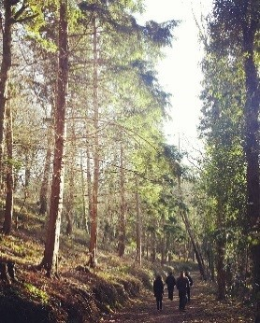
The woodland occupying 14.5 acres, known as Coed Llys is believed to have been in existence since @1600. Pre 1965-70 Coed Llys was a mature oak-dominated mixed broadleaved woodland extensively felled and replanted with conifers. Surviving oaks have formed a nucleus of seed trees, with native species gradually regenerating the woodland to a full broadleaved woodland canopy supporting plant species typical of semi-natural woodland and ancient woodland indicators.
Geologically the woodland part of a larger lowland landscape with deeply incised and steep valleys cutting through the boulder clay into the carboniferous shales and sandstones, the remaining area of woodland and grasslands are on flatter and more gently undulating land, is located on glacial tills of clays, sand and gravels.

The woodland forms two broad woodland types; Mixed Conifer/Broadleaved Woodland Type and Conifer dominated Mixed Woodland Type; within both these types there are small pockets of damp woodland.
Historically, running the entire length of the wood is the distinct embankment of Watt's Dyke which is a scheduled ancient monument.
Mixed Conifer/Broadleaved Woodland Type - Woodland on the steep west-facing valley slopes are of mixed tree composition in terms of both species and age range. Conifers remain among regenerating broadleaves and trees surviving from the pre-conifer era. The conifers are a mixture of Sitka spruce (Picea sitchensis), Douglas fir (Pseudotsuga menziesii) and western hemlock (Tsuga heterophylla).
At the far north end there are red oak (Quercus rubra), above the main trees have been heavily thinned to encourage the restoration of the woodland back to broadleaves which include within the matrix of conifers, sycamore (Acer pseudoplatanus), ash (Fraxinus excelsior), oak (Quercus sp.), silver birch (Betula pendula) with the occasional wild cherry (Prunus avium), goat willow (Salix caprea) and rowan (Sorbus aucuparia).
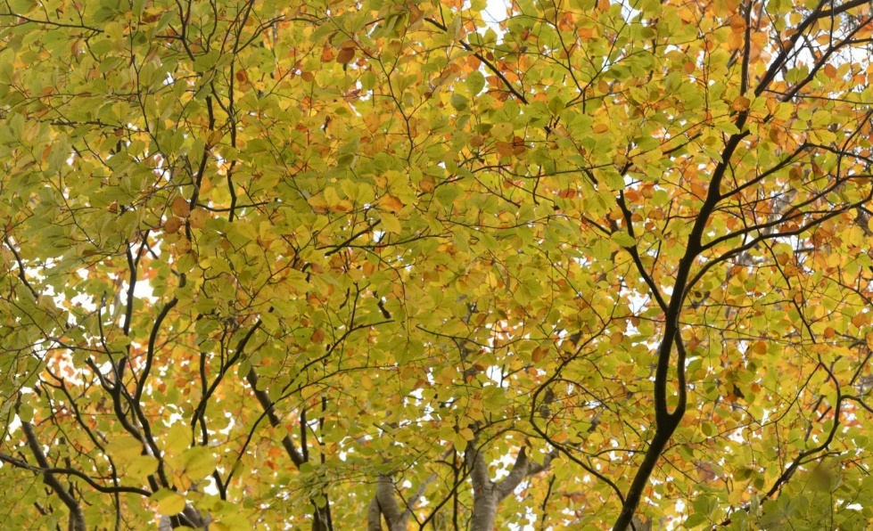
The understorey includes dense natural regeneration of ash and sycamore, occasional oak and rowan, wych elm (Ulmus glabra), holly (Ilex aquifolium), hazel (Corylus avellana) and elder (Sambucus nigra).
Hazel in Autumn

Within the largely dominated conifers woodland with field layer plant species many ancient woodland species characteristic of acid soils have survived .
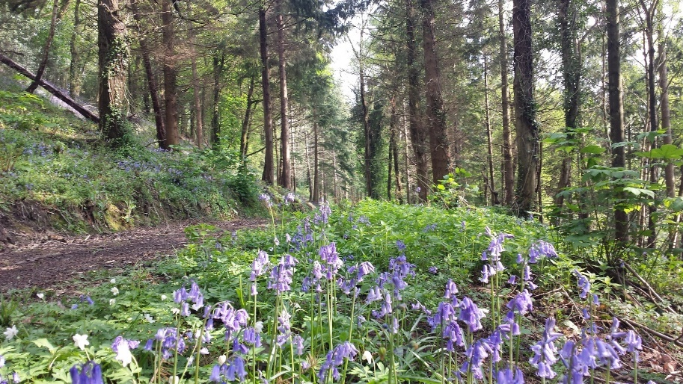
Typical species include bracken (Pteridium aquilinum), male fem (Dryopteris filix-mas), broad buckler fem (Dryopteris dilitata), hard-fem (Blechnum spicant), great wood-rush (Luzula multiflora), false-brome (Brachypodium sylvaticum), hairy-brome (Bromopsis ramosa), ivy (Hedera helix), foxglove (Digitalis purpurea), honeysuckle (Lonicera peryclymenum) and bluebell (Hyacinthoides non­scripta).
Bluebells in Spring

Ancient woodland species exist in the open areas of the wood supporting a more diverse range of woodland species, dense stands of enchanter's nightshade (Circaea lutetiana), dog's mercury (Mercurialis perennis) and ramsons (Allium ursinum) are able to flourish. Other species recorded include common dog violet (Viola riviniana), wood sage (Teucrium scorodonia), wood sorrel (Oxalis acetosella), wood avens (Geum urbanum), wood anemone (Anemone nemorosa), yellow archangel (Lamiastrum galeobdolon), woodruff (Galium odoratum), yellow pimpernel (Lysimachia nemorum) and wood dock (Rumex sanguineus).Approximately half way along and above the main track is a small disused quarry. Here the ground is heavily shaded limiting plant growth to scrub, wych elm (Ulmus glabra), sycamore and wild cherry regeneration. Separate plants of the relatively uncommon broad­leaved helleborine (Epipactis helleborine) were found in two places at the woodland edge to the east of the main track.
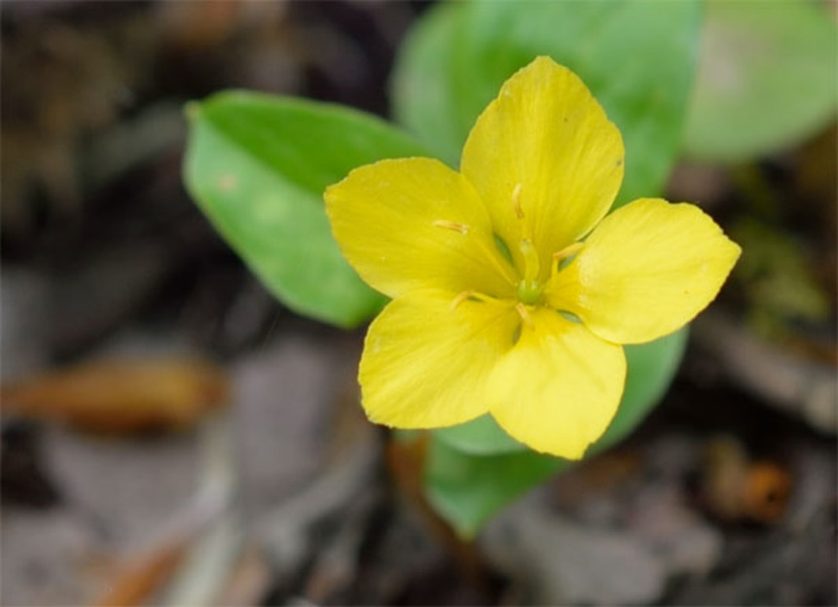
Conifer dominated Mixed Woodland Type - The woodland located on the flatter and gentler slopes of Coed Llys are much more uniform in composition and age. There are extensive areas of Norway spruce (Picea abies) together with a variety of broadleaf species including sycamore, birch, ash and goat willow which also form the canopy. Horse chestnut (Aesculus hippocastanum) trees occur in this part of the woodland together with a number of semi-mature beech (Fagus sylvatica. The lighter areas of the woodland floor field layer include some of the species characteristic of the woodland type above. Wood sorrel and fem which extensively carpet the woodland floor with ramsons, wood speedwell (Veronica montana) and yellow pimpernel forming smaller dense patches. The monitoring for Ash die back has also been looked at in 2022 showing a higher incidence of effected trees
Yellow Pimpernel

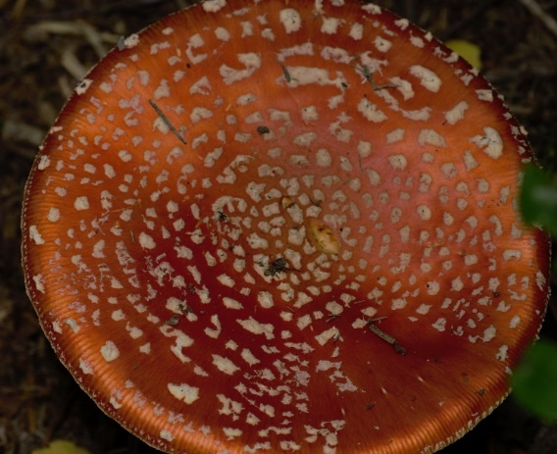
A network of low stone walls which are understood to have been built by prisoners of war in the early 1940's can be seen in the south west comer. Rhododendron (Rhododendron ponticum) has become established on one of these walls but does not appear to be spreading. The spectacular fly agaric fungus (Amanita sp.) are often found associated with the birch trees.
Fly Agaric

Damp woodland has formed on lower-lying and damp ground at the base of the slopes near the centre of this area. Here more lush vegetation thrives with tufted hair-grass, soft rush, sedges, creeping buttercup, marsh thistle and marsh figwort (Scrophularia auriculata), with also abundant common spotted orchid (Dactylorhiza fuchsii).

Coed Llys Woodland Strategy
- Open up main central track and alongside the river corridor by thinning and coppicing will provide more light, encourage regeneration and increase biodiversity.
- Monitor river to ensure there is no damming, over silting and to ensure there is no damage to the existing ecosystem check for the presence of Himalayan Balsam.
- Protect unusual and rare species (broadleaved helleborine and common spotted orchid) ensuring that other woodland activities do not impact upon them and are compatible with the management objectives.
- Create Habitat piles:
  - The number of habitat piles should be restricted
  - Allow air flow and freedom of movement for invertebrates and small mammals
  - Place habitat piles to allow for some direct sunlight throughout the day to increase biodiversity; the net result is that a living ecosystem is created providing a valuable food source for birds, amphibians and mammals rather than just a bug farm.
- Ensure that woodland management activities are outside bird nesting season March-August
- Ensure that no woodland activities or replanting occur on ancient monuments.
- Increase in bird, bat and insect boxes
- Monitor for Ash Die back

Biodiversity and Ecosystem Resilience Duty Delivery Plan Schedule
Activity |  | Date

Coed Llys Woodland
Thin / coppice trees with low wildlife value to increase woodland edge wildlife alongside river corridor. The coppicing of hazel will be used to integrate into hawthorn hedges – see Hedgerow | February to March 2022 ongoing
Monitor river for damming or over silting | On-going
Monitor river for Himalayan Balsam | March – July ongoing
Identify areas containing rare and unusual plants | May – September 2022 -2025
Monitoring of Owl box on periphery of forest | On-going
Monitoring of bird boxes, planned increase of bird boxes in this area | March – June 2022 and Feb –March thereafter 2023 -2025
Inclusion of awareness of activities with the forest school to promote awareness of habitats and future projects | On-going
Monitor for As die back | 2022 – on-going

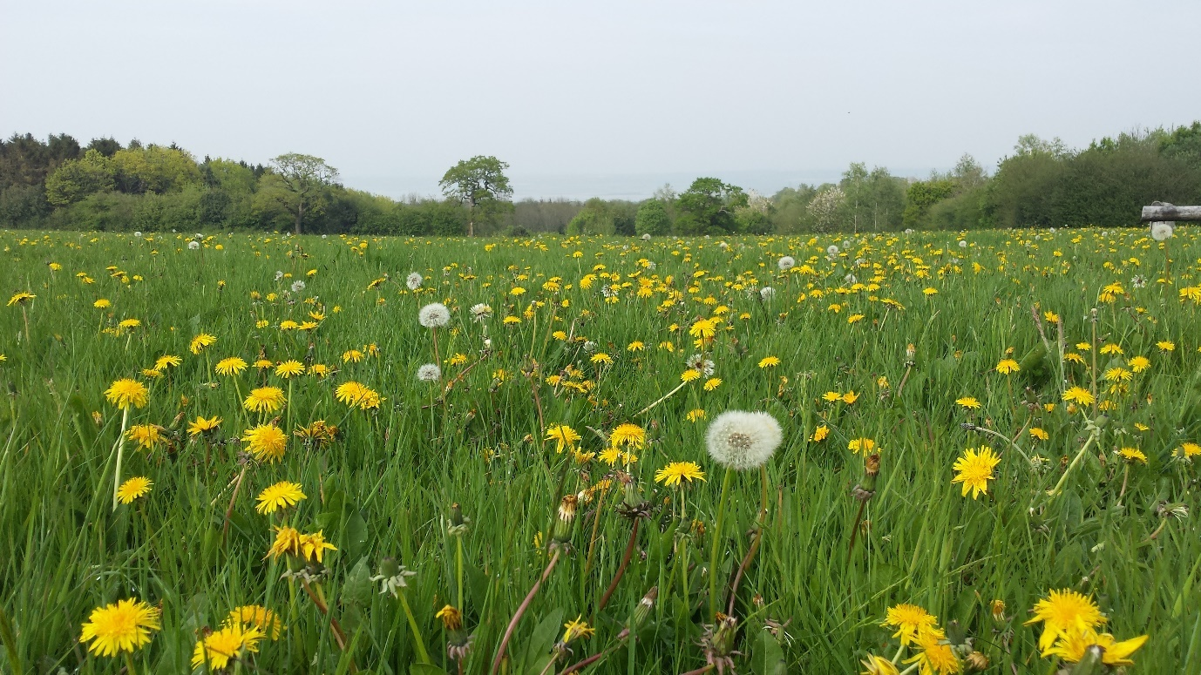
Improved Grassland

All of the management techniques that have been employed since 2013 with some improvements have proven to be beneficial to biodiversity, either stabilising or enriching the ecosystems there for the current systems are set to stay in place until at least 2025.
Hay Meadow - The two large fields of 9.5 hectares located between the university and Coed Llys are being managed as traditional hay meadows. They are classified as improved grassland containing mostly agricultural/amenity grass mixes with few other grass and herbaceous plant species. They are both managed as hay meadows.
The northern field is dominated by a grass mix of Yorkshire fog, fescue (Festuca) species and bent (Agrostis) species, with cock's-foot locally dominant. Rye-grass and white clover (Trifolium repens), species of improved grassland were also recorded.

Scattered throughout the meadow are other plant species more typical of semi-improved and unimproved grassland and include crested dog's-tail, meadow foxtail, common knapweed, meadow buttercup (Ranunculus acris) and creeping buttercup with also cat's-ear (Hypochaeris radicata), dandelion (Taraxacum officinale), common mouse­ear (Cerastium montanum) and ribwort plantain. Hogweed and dock are also scattered throughout the meadows.

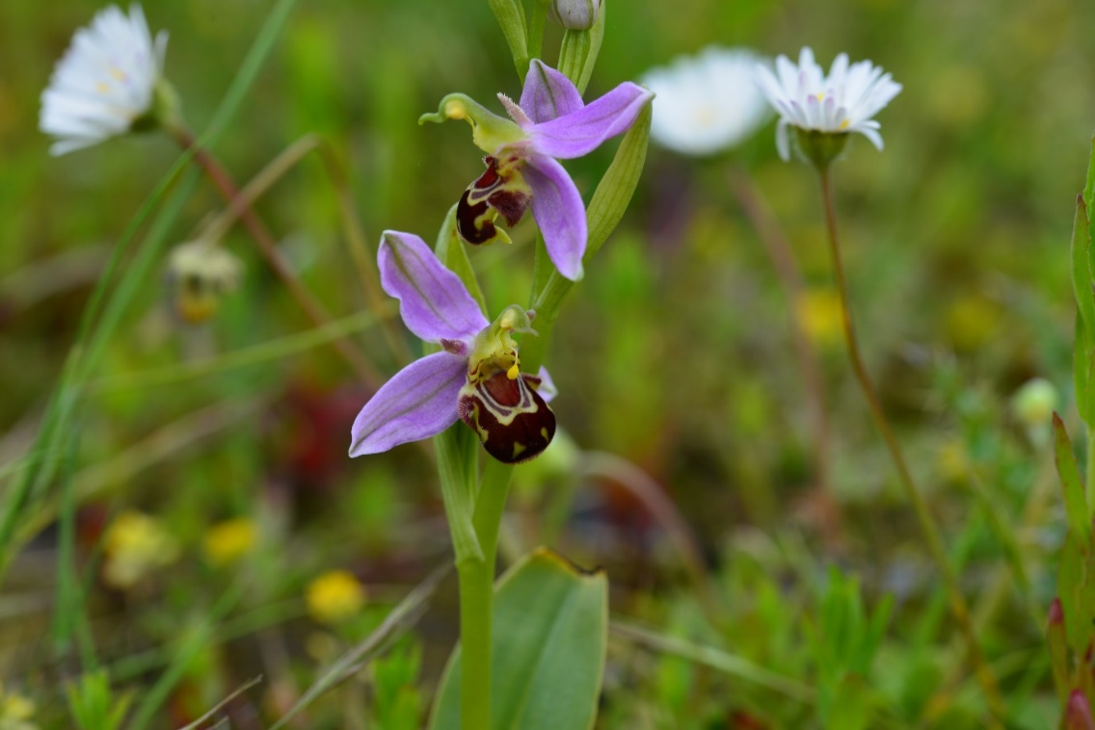
The southern field is of similar composition and has a small colony of bee orchid (Ophrys apifera), a species which normally favours calcareous and low nutrient soils with up to 10 individual plants.
The field edges alongside the hedges support more typical wayside plants such as self-heal, hedge woundwort, thyme-leaved speedwell and hogweed as well as creeping thistle, spear thistle (Cirsium vulgare) and nettle. On the eastern side the fields are bounded by overgrown hedges consisting of a mix of holly, hazel and hawthorn, with a small amount of additional planting including willow, ash and wild service tree (Sorbus torminalis).
Bee Orchids

Hay Meadows Strategy
- Check and action activities required by guidelines using the methodologies of Tir Gofal (an Agri-Environmental Scheme) continuing with low input - low intensity sustainable management system to only cut the meadow once per year
- Continue traditional hay meadow management, with late cut from mid-July to mid-August to avoid ground-nesting birds and rare plants; this also allows for plants critical to the ecology and management of the meadows to reseed e.g. yellow rattle.
- Leave cut sward no less than 15-20cms height. This allows the remainder of the plant to pull back nutrients into the roots for the following year or to act as a natural fertiliser
- Avoid application of artificial fertilisers
- Avoid use of herbicides. If necessary, cut weeds docks, thistles and ragwort during flowering (ongoing)
- Use wildlife-friendly mowing practices such as cutting field from centre outwards or mowing in strips from one side of the field to the other
- Fence and delay cutting in vicinity of bee orchids and helleborines the latter of which tend to flower later
- If wildflower seeding is being considered, ensure seed of local provenance is used and is utilised only in selected areas
- Leave strips (minimum three metres) of uncut meadow along the margins between fields and hedges to act as wildlife refuges and food sources, as well as a wildflower seed source.

Why are these strategies so important to biodiversity?

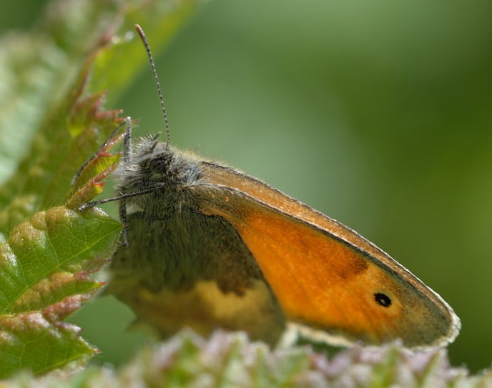
Bee orchids and butterflies, such as meadow brown which are typical of such grasslands with many species being dependent on grass species to lay their eggs so care needs to be taken to allow for seasonality because of climate change, if the meadows are cut too early then the very ecosystems we are aiming to protect could be destroyed
Meadow Brown Butterfly

Bird species such as warblers and wrens will potentially nest amongst the tall vegetation with the hedgerows and wide field margins providing valuable wildlife connectivity strips and allowing nesting and food sources for a variety of bird species.

The current traditional hay meadow management, cutting after mid- July to late August, together with a low input management serves to reduce nutrients and favours a gradual conversion to a more species rich meadow increases biodiversity value.
Field margins often contain completely different ecosystems to the field they contain, however the ecosystems are linked so if you damage one habitat you damage the other, it is all about balance. Often specific flora and fauna are found in these margins, Hedge woundwort and some of the umbellifers such as Cow Parsley thrive . In one area we have a margin of blackthorn which give us a healthy population of true bugs (Hemiptera) and could potentially attract hairstreaks to lay their eggs in the area.
As well as ecosystem links between the meadow and margin the value of the informal link between the field margin and other habitats such as woodland and hedgerow should not be underestimated.
This current management also appears to favour the bee orchid, usually associated with open habitats on calcareous/clay soils clay soils and banks where the grassland turf is comparatively short.
Orchids that take a long time to flower after germination, require a mycorrhizal fungus to germinate and numbers can fluctuate from year to year. As the main flowering period is June-July strategy dictates that we look for evidence that bee orchids have produced their seed capsules otherwise they require sectioning off to avoid being cut.
Over the course of 2021 partly due to the Covid crisis and partly to examine the environmental impact, the hay meadows were left uncut in 2021 year to give better coverage for birds and insects.
In 2022 we are aiming to assess how this has affected the flora and fauna of that area by recording species by abundance as well as presence; hopefully encouraging new species.
Field margins have also been left especially where there is blackthorn to encourage species that are dependent on this as a food source.
Monitoring will take the form of a recorders day on the 20th August 2022. Data will be compared to information collated from the Bioblitz 2019
All above strategies are on-going and will be re-assessed in 2025
Former Golf Course Approximately 2.1 hectares or one third of the former golf course is within the university land. The upper section below the track is managed in a similar way as the two hay meadows but has a similar plant species composition, with a mix of Yorkshire fog/fescue/bent/cock's-foot grasses with white clover.
There is a less diverse range of herbaceous plants including creeping buttercup, cat's-ear, dandelion, knapweed, hogweed, mouse-ear chickweed with dock and ragwort scattered throughout, this area which seem to be of particular interest to the Ashey’s mining bee (Andrena cineraria) .
Rough grassland with creeping thistle, spear thistle, hogweed and nettle are more prevalent along the field edges next to the hedge. The sandy 'bunkers' are gradually becoming colonised by bent grasses and Yorkshire fog, these bunkers are frequented by mining bees which attracts often the parasitic and forever active dark-edged bee-fly (Bombylius major).
Buzzards are regularly seen hunting over this area.
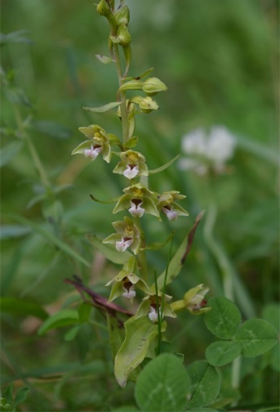
The former course is broken up with mixed broadleaves that are well established. They consist of silver birch, grey alder (Alnus incana), common alder, oak, lime (Tilia sp.), rowan, wayfaring tree (Sorbus lantana), goat willow, crab apple (Malus sylvestris), hawthorn, guelder rose (Viburnum opulus), spindle (Euonymus europaeus), with also the conifers Scot's pine (Pinus sylvestris) and Corsican pine (Pinus nigra ssp laricio).
The grassland areas around the edges of the plantings are left uncut. Broad-leaved helleborine has been recorded here on the track dividing the sports field and the golf course and is always taped off during the cut as it is one of the late British flowering orchids
The rough grassland including uncut edges provide feeding grounds for species such as buzzard and provide nesting and feeding habitat for birds and hibernation sites for insects during the winter.
Broad-Leaved Helleborine

All cutting strategies deemed beneficial to the increase or continuation of levels of biodiversity as mentioned above will be continued until reviewed in 2025

Semi - improved Amenity Grassland (Sports/playing field)
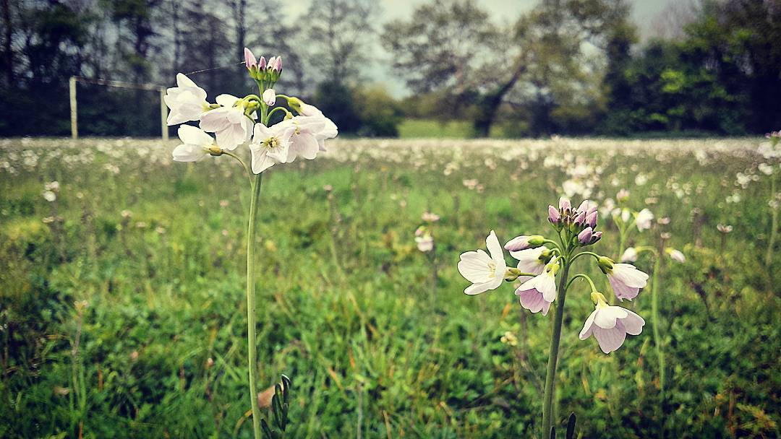
This field of 1.9 hectares was once mown regularly; formerly a sports field for the students. It is now mown once a year as per the hay meadow and former golf course. It is largely surrounded by belts of mixed broadleaves with a scattering of conifers. Species include Turkey oak (Quercus cerris), birch, sycamore, poplar (Populus sp.), rowan, Norway maple and (Acer platanoides), with rough grassland dominated by; creeping thistle, hogweed, dock and nettle below.
Cuckoo Flower

Since the regularity of mowing has been reduced there has been a proliferation of, Cuckoo flower, (Cardamine pratensis) a valuable food source for the Orange tip butterfly (Anthocharis cardamines) there has also been a resurgence of Hedge Woundwort (Stachys sylvatica) in the field margins providing woodland edge habitat for the commoner species of birds and insect biodiversity.
Biodiversity and Ecosystem Resilience Duty Delivery Plan Schedule as per Hay Meadow

Biodiversity and Ecosystem Resilience Duty Delivery Plan Schedule
Activity | Date

Hay, Former Golf Course and Sports Field
Late cut mid – July to mid - August (cut by contractors) however because of the monitoring schedule we are looking to cut after the 20th August 2022; subsequent years will fall back onto the previous schedule | August 2022  Thereafter July to mid - August 2023 - 2025
Late cut mid-July to mid - August (cut by contractors) however because of the monitoring schedule we are looking to cut after the 20th August 2022; subsequent years will fall back onto the previous schedule | August 2022  Thereafter July to mid - August 2023 - 2025
Former Golf and Sports field.
Cut upper parts as hay crop (see above) | August 2022 thereafter 2023 -2025 July to mid - August (cut by contractors)
Maintain rough grassland along the margins of the wooded strips and hedgerows | On-going
Tape off rough grassland edges with helleborine and exclude from cutting.  Assess numbers and spread 2022 - 2025 | Helleborine, a late flowering member of the Orchid family –July/August
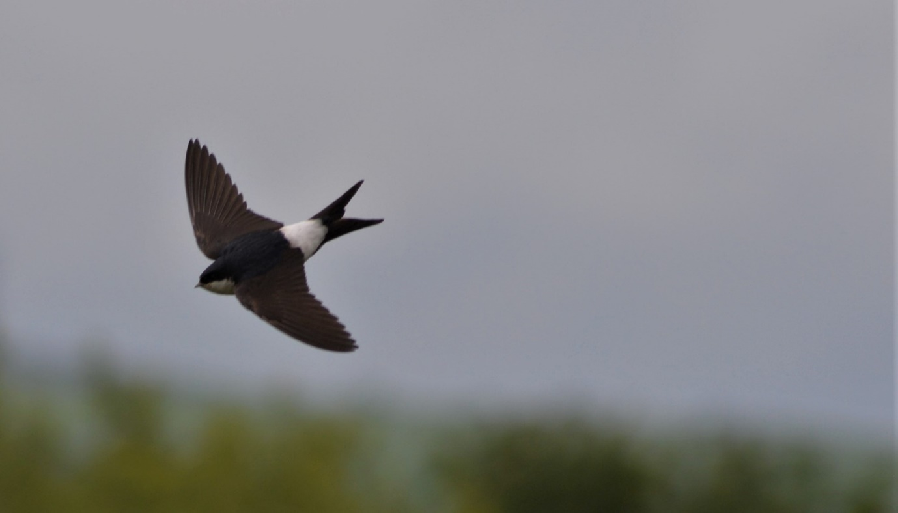
High above the grass, the proliferation of invertebrates attracted by the flowers produces avian activity.
House Martin

Wetland / Open Water (Formal Pond)
Ponds provide important habitats for a range of wildlife including insects, reptiles and amphibians which are dependent on open water and pond vegetation. The pond was originally a formal pond created within a shrubbery and has been planted with a mix of native and introduced plants.
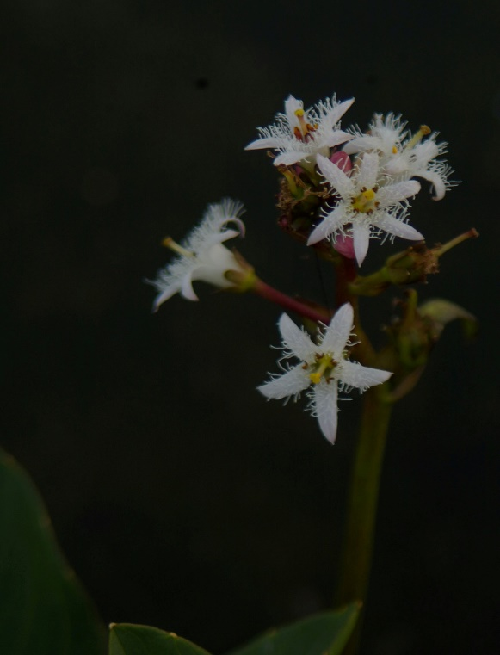
The emergent plants reedmace (Typha latifolia) had colonised most of the shallow silty waters of the pond. Sedges form dominant stands around the fringes of the pond and include both an introduced striated variety as well as lesser pond sedge (Carex acutiformis). Bogbean (Menyanthes trifoliata), possibly introduced as their natural habitats are typically peaty soils.
Water plantain (Alisma plantago-aquatica) also thrives in the shallow water. The floating white water lily (Nyphaea alba) is conspicuous while the submerged plant water starwort (Callitriche sp.) forms dense stands beneath what remains of open water. In damp soils around the pond marsh plants thrive and include hoary willowherb, meadowsweet, purple loosestrife (Lythrum salicaria), the introduced monkey flower (Mimulus guttatus), flag iris (Iris pseudocarus) and yellow loosestrife (Lysimachia vulgaris). The edges are also being colonised by white poplar (Populus alba), goat willow (Salix caprea) and Italian alder (Alnus cordata) which has attracted the once rare Alder leaf beetle (Agelastica alni) that was found on our site mid-2018.
Bogbean

Biodiversity Value /Management
A brief history
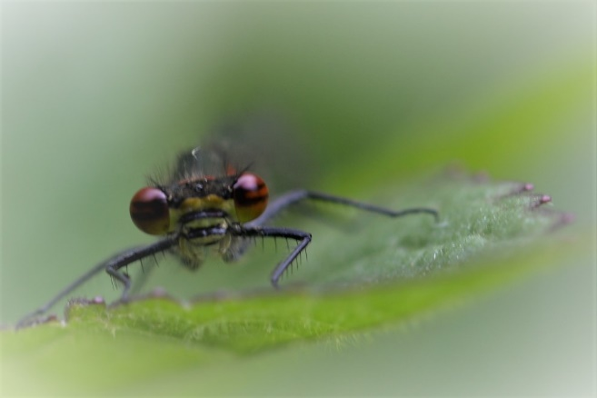
In 2019, when the campus had a bioblitz, the results proved that the hard work had allowed for many new invertebrates to thrive including the proliferation of new dragonfly/damselfly species and exuvia; Southern Hawker (Aeshna cyanea), Large Red Damselfly (Pyrrhosoma nymphula) and Common Darter (Sympetrum striolatum). We will use the data from 2019 to assess the environmental impact of the latest clearance work
Large Red Damselfly

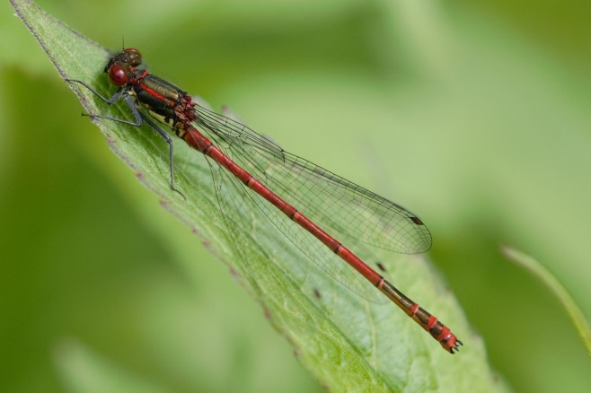
Corrugated mats were provided by the Amphibian and Reptile Conservation organisation (ARC) to promote and increase the Toad (Bufo bufo) population.
Large Red Damselfly

Over the course of 2020/ to early 2021 the pond was becoming silted with Reedmace encroaching into the middle of the pond, Bogbean forming a carpet layer and increased growth of Yellow Iris with a reduction in the depth leaving only shallow areas of semi clear water which was further affected by duckweed.
In the early part of 2022 pond clearance activities were planned but Covid was still depleting us of resource and we were unable to acquire the necessary volunteers to maintain the pond to a reasonable standard. Work has to be finished ideally before mid - March to allow for Great Crested Newt
Current work
We have felled some of the Italian Alder on the north side of the pond to provide more light and promote biotic activity. The felling should promote a coppice effect to give ground cover for the newts and toads that we currently have in the pond and mammalian, invertebrate populations should also benefit; this also takes into consideration the populations of the Alder Leaf Beetle which were thriving in that area last year.

Futures
To promote awareness of the presence of the Great Crested Newt and with the help of ARC by (Amphibian Reptile Conservation organisation) providing education to encourage more survey work to be performed in the future.
Grant options for pond clearance and the creation of new ponds have now been submitted by ARC and are awaiting approval.
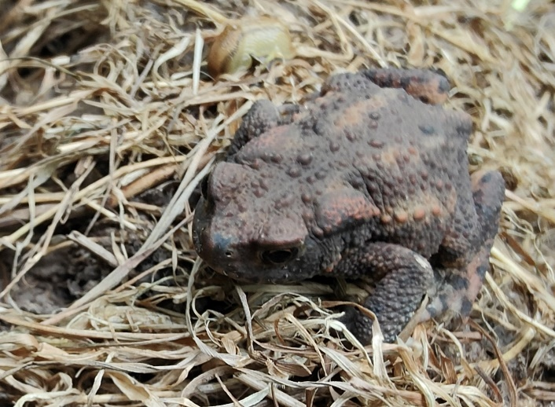
To re-establish hibernacula for Toads around the surrounding area.
Common Toad

To, through the use of volunteers, create specific toad runs from hibernacula to hibernacula.
To, as a result of additional training consistently survey the pond areas for Great Crested Newt and Toad populations and build hibernacula for grass snakes to attract then to the area.
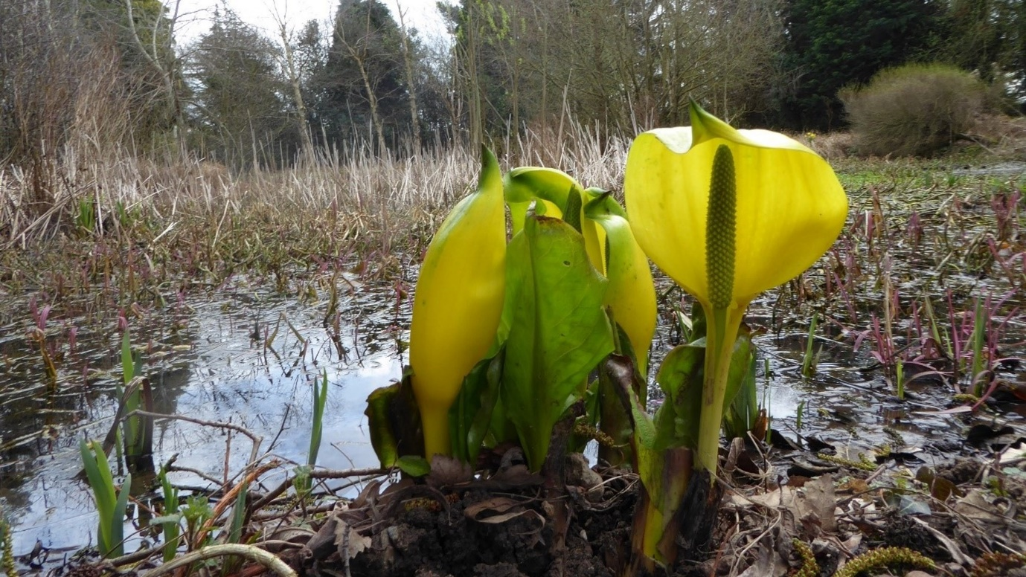
In 2017 in the main pond we had American Skunk Cabbage. Stem injections of glycol-phosphate were used to curtail the proliferation of this invasive species by our local INNS officer in 2018 and appear to have killed off all but one of the six specimens.
American Skunk Cabbage

This specimen is regularly de-seeded as it was in May 2022 but still persists through rhizoidal growth.

Formal Pond strategy
- Assess drainage problems with pond and catchment and rectify 2022 - 2025
- Selectively remove reedmace stems and rhizomes which are encroaching across the shallow open water area. October 2022 either with or without ARC – see above
- Check for presence of Great Crested Newt before undertaking pond restoration or other works
- Manage north facing Italian alder which is home to the red data list Alder Leaf Beetle (Agelastica alni) which has migrated from the car park to the pond perimeter: coppice once every two to three years, depending on growth, manage encroachment and water drainage by the proliferation of saplings. This activity will provide more light for the pond encouraging further diversification and invertebrate activity. Coppiced 2022, coppice renewal 2024/25

- Inspection and monitoring the presence or absence of the invasive species American Skunk Cabbage (Lysichiton americanus) around the formal pond, associated drainage paths and river system – on-going. Previously, plants found on or near the ponds perimeter were stem injected with a glycol-phosphate solution to avoid contamination to other aquatic life forms by the local invasive species officer. If there is a re-occurrence of this species biosecurity measures will be put in place in-line with NNSS (GB Non-native Species Secretariat) On-going
- Strimming around the borders of the pond to allow for re-growth and control of nettles during the Sept – November period, to allowing for dragon/damselflies to disperse and exuvia to have been vacated:
This practice appears to have stimulated ichneumonoid activity in the area allowing the first recording of the Ichneumon Perilissus albitarsis ever in Wales and the presence of the rare Acrodactyla quadrisculpta; another ichneumonid parasitic wasp. October 2022
- Increase in bird, bat and insect boxes. Bat boxes are made, poles are awaiting hardening and placement to natural vegetation to avoid climbing.

- Avoid introduction of fish species. However there were reports of fish in the run off ditch south of the pond; monitoring of fish species presence and abundancy.

Biodiversity and Ecosystem Resilience Duty Delivery Plan Schedule

Formal Pond
Assess drainage problems with pond and catchment | On – going
Check for presence of Great Crested Newt prior to pond restoration | On-going and selectively if new projects potentially impact
Selective removal of reedmace stems and rhizomes. Presence of Great crested Newt may delay this process; work will proceed when the Great Crested Newts are hibernating out of the water, inspections for newts will be done prior to clearance. Both conservation and Newt licences have been acquired | October 2022 management on-going
Select alder to be saved for high level foliage to sustain red data list Agelastica alni -Alder leaf beetle. | To be reviewed late 2023, early 2024
Manage north facing alder – coppice in two year rotation. | Coppiced, next coppice cycle 2024/25 Not to be coppiced before abscission; process 3 detachment.
Inspection for presence or absence of invasive Lysichton americanus – American Skunk Cabbage | March 2022 - 2025
If present de-seed and contact INNS (Invasive non-native Species officer) | August –September 2022 – start of die back
Strim borders of the pond – dependent upon abscission | April 2022 . Monitoring May 2022 -2025
Creation of bat / bird poles to be created from alder and lashed to existing trees | 2022-2023  Increase subsequent years; vary types of bird box e.g. New bird boxes for long tailed tits which frequent the area
Additional Bat/ bird boxes to be erected along surveyed transect = 3 | 2022 / 2023
Dipping for fish species | On-going

Hedgerow
Hedgerows are often overlooked, they provide valuable wildlife cover for small mammals, birds, invertebrates and flora that require part shade. Plans are included to increase biodiversity by adding two or more species within the same hedgerow providing the ecosystems do not conflict
Hedgerow habitat is present on the campus used as borders, dividing fields, fields and edging around the patio areas and borders between woodlands and field margins.
The majority of our hedgerow is hawthorn (Crataegus monogyny), blackthorn (Prunus spinosa) and hazel (Corylus avellana) often mixed with ivy (Hedera helix .agg) bramble (Rubus sp.) and Holly (Ilex aquifolium)
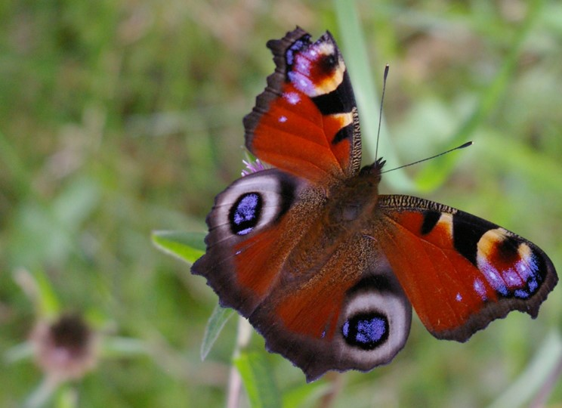
They are valuable breeding sites providing food and shelter for many pollinators, bumblebees, solitary bees, hoverflies, and beetles. Butterflies such as the holly blue lay their eggs on Holly and sometimes Ivy, Red Admirals and Peacocks which are territorial will sometimes define their territories along the hedgerow
Peacock Butterfly

Orange tips and Speckled Wood, although typically a woodland species, will use the hedgerow as a transect line in the same way. Several members of true bug (Hemiptera) can also be found on hedgerow
Rabbits, mice, voles and shrews form burrows using the root structure for protection and support as do some of our badger population.
Birds such as sparrows, dunnock and finches will use hedges for food, nesting and cover from predators particularly raptors. Sparrowhawks have been recorded on the site following the lines of the hedge to find an unsuspecting birds or mammal. Wrens are also another bird that frequents the hedgerow.
Corrugated sheets have been placed on both sides of some hedgerow to act as cooling areas in the shade for toads and warming stations for lizards, slow worms and grass snakes. Currently we have only recorded toads.

Hedgerows Strategy
- Trim late in the winter season, ideally in February but before bird’s nest in March, to provide valuable food source for wintering birds
- Implement trimming schedule to maintain tall hedges but controlling width
- Plant developing gaps in hedge with native shrub species
- Select and protect suitable developing tree saplings
- Allow ground flora to develop beneath to encourage thick and dense cover at base of hedge (ongoing)
- Maintain an uncut verge approximately three metres width alongside hedge (ongoing)
- Time cutting of vegetation to avoid bird nesting season March – August
- Control coarse weeds thistles, docks and ragwort (at flowering), subject to no birds nesting as for hay meadow.
- Do not apply artificial fertilisers or herbicides. (ongoing)
- Undertake scrub control where invasion threatens species-rich pasture. (ongoing)
- Leave strips (minimum three metres) of uncut meadow along the margins between fields and hedges to act as wildlife refuges but with top control Feb/early March
- Implement a hedge cutting policy to prevent fencing becoming overgrown
- Environment (Wales) Act 2016 section 7. Dunnock (Prunella modularis) no further action required due to above management.
- Check corrugated sheeting for toads, lizards, slow worms and grass snakes.

Biodiversity and Ecosystem Resilience Duty Delivery Plan Schedule – Hedgerow
Activity | Date

Hedgerow
Winter trim | February 2023 in areas where Dunnock habituates – on-going whist species present
Scrub control | September 2022 – 25
Margin check prior to cutting meadow areas (broad leaved helleborines, bee orchid and common spotted orchid) | Mid Jul August 2022 - 25
Margin check prior to cutting meadow areas | August / September 2022 -25
Monitor ground flora and dense undergrowth to all provide cover for priority species; Dunnock, allow some clear areas for re growth of new species – balance. | On-going
Clear corrugated sheets from vegetation for amphibians and reptiles | Winter: February / March, under review due to potential disturbance of hibernating Amphibians and Reptiles

Planned activities additional to standard maintenance and monitoring is the introduction of coppiced Hazel to the existing Hawthorn hedgerow to increase biodiversity and provide protection and cover for birds, mammals, possibility of attracting the Hazel Dormouse (Muscardinus avellanarius) and invertebrates

Other
Hedgehogs
Our Wrexham campus volunteers have attained the silver award for being a hedgehog friendly campus, this is an on- going process, the team are now working towards the gold award.
https://glyndwr.ac.uk/blog/posts/hedgehog-friendly-campus/

Forest area near residential buildings
An initial tidy of the forest area has been started. The following is planned
To build a composter.
To look at building a grass snake hibernacula as even though it is several hundred yards from water there is no possibility of flooding and grass snakes are known to travel large distances for their food.
Newt hibernacula, planned for late autumn 2022 as Great Crested Newts (GCN) often migrate a fair distance from ponds to hibernate.
Although we have Badgers on site which do not normally mix well with hedgehogs there have been no badger sightings in this area, a hedgehog hibernacula is going to be placed in this area and monitored.
Very recently Polecats have been seen near to the Corbishley area; investigation planned to encourage Polecats
The area is open and shaded with a fire pit backing on to a patio and lends itself well to areas of meditation and well – being for todays pressured social arena. By introducing more wildlife, both flora and fauna plus a bench or wooden logs we hope to establish an area where wildlife and humans have some symbiosis as a valuable area to improve mental health

University Buildings
The university buildings are mainly modern in structure but there is a possibility they could be used as bat roosts for common and soprano pipistrelles for breeding and hibernation. Surveys recorded their presence by the transects close to the pond and its outlying woodland borders, more surveys are planned with a view to attract bats further away from the building and closer to the pond where they are less likely to be disturbed.

University Buildings and outlying areas strategy
- Erect bird nesting boxes – sparrow, robin, long-tailed tit.
- Erect bat boxes on bat poles near to pond area
- To attract pollinators bee boxes are to be erected close to the accommodation area, gardens and patio area. This is to promote greater presence of solitary bees particularly Adrena sp. which are valuable pollinators in the fields and have been seen on the former golf course.
- Survey for bats
- Continuation of the research and removal of the Harlequin Beetle (Harmonia axyridis) which emerges each year in the accommodation block between late February and April diminishing the native populations of ladybirds.
- Monitor for hedgerow section 7 priority species Dunnock (Prunella modullaris) which frequents the low hedges around the two main buildings. Surveys to be performed across campuses

Biodiversity and Ecosystem Resilience Duty Delivery Plan Schedule – University Buildings and immediate surrounding areas 2022-2025
Activity | Date

University Buildings and surrounding areas
Erect bird nesting boxes – sparrow, robin, (all sites) long tailed tits subject to survey, we have long tailed tits on site spotted by and near the pond at Northop but also on the willow by Corbishley. | Pre April 2023 on-going
Bee boxes for solitary bees see notes above | Pre April 2023 on-going
Survey for bats | On going
Initial Assessment of the St Asaph site planned June / July 2022
Harlequin beetle research and removal | On going
Monitor ground flora and dense undergrowth to provide cover for priority species; Dunnock, allow some clear areas for re growth of new species – balance. All sites. | On-going

Note
Ensure that consideration is given to the possible presence of bats and nesting birds before any building works or other modifications are carried out.

Monitoring and Recording
Monitoring and recording are the cornerstone of assessing biodiversity without recording at monitoring at species level and understanding the ecosystems the individual species are within we cannot assess what we need to conserve or which habitats we need to protect.

History
From 2016 to 2019 there has a been a gradual increase in the recording and monitoring assessments in order to understand what needs to be conserved, managed and sustained.
Due to Covid during 2020 -2021, the monitoring was very limited due to lack of resources, From April 2022 we aim to re-establish periodic recording dependent upon resources.

Current
There is a recorders day on the 20th August 2022 from which we might be able to assess impacts of climate change
Possible monitoring days to be arranged for St Asaph and exploration of rare plant development with Denbigh County Council 2023
Greater involvement with hedgehog team and biodiversity staff using the knowledge of botany and entomology to encourage this endangered mammal
Spider and other invertebrates walks and talks are also part of an initiative with Cofnod.
Links to Cofnod have been re-established and any courses available will be made available to staff and students via newsletters
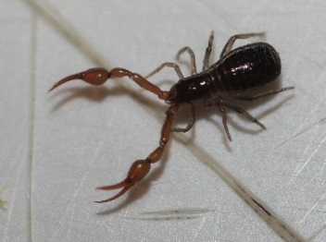

Pseudoscorpion : Neobisium carcinoides

Species Lists
2018 species list
This culminated with the Bioblitz in June 2019
Species lists were limited during 2020/21
New Species lists will be available from the monitoring day in August 2020 compared to the baseline data from 2019

BIOBLITZ Northop campus June 2019
This event provided valuable information for assessment, monitoring and prioritisation of species, gave the university campus a greater local presence, strengthened our partnership with Flintshire County Council and Cofnod, our the Local Environmental Recording Centre.
The Bioblitz produced nearly 600 records and nearly 392 species recorded showing a relatively high level of biodiversity for the area and multiple micro ecosystems. Several species were recorded for the first time in Flintshire and some had never been recorded at all in North Wales; our thanks to the many hours of dedicated work by the student volunteers, NGO’s and recorders on the day.
The link for the Bioblitz results is https://www.cofnod.org.uk/Results?ID=50
Species List.
As a result of the Bioblitz and the 2019 species list we are now we are now more aware of what we need to conserve and have been provided with a list of priority species see the Environment (Wales) Act 2016 section 7 see section seven mechanism below.

Biodiversity and Ecosystem Resilience Duty Delivery Plan Schedule Monitoring and Recording
Activity | Date

Recording for Biodiversity
Recording of species | on going
Records in to Cofnod | August 2022
Summation of Cofnod totals | 1st December 2022
Notification of priority species section seven species | January 2023
Insertion of priority species to Biodiversity Action Plan | March 2023
Biodiversity summation | March 2023
New Records to Cofnod 1st May | 1st May 2023
Summation of Cofnod totals (to take into account comparisons to Bioblitz to show increases or declines at species level) | 30th June 2023
Summary Report and recommendations | 15th July 2023
All records to Cofnod - Yearly Records in to Cofnod | 1st November 2023
Summation of Cofnod totals | 1st December 2023
Addition to priority species | 1st December 2023
Insertion of priority species to Biodiversity Action Plan | 05 December 2023
Biodiversity comparison report (a working document) with priorities and recommendations based on recorded data | 15th January 2024

Environment (Wales) Act 2016 section 7

Species lists within a legal framework have changed from Natural Environment and Rural Communities Act 2006 - Species of Principal Importance in Wales section 42 to the Environment (Wales) Act 2016 section 7 see section seven mechanism below.
These species are flagged to the university by Cofnod upon recording as, according to the act ‘species of principal importance for the purpose of conserving biodiversity and therefore need to be taken into consideration by the public body when performing any of its functions with a view to conserve’. The species that are highlighted will be included against their habitat with any action required.
The priority species flagged for 2019 were as follows
Species Group | Scientific Name | English Name | Welsh Name | Year
Birds | Larus argentus | Herring Gull | Gwylan y Penwaig | 2019
Birds | Passer domesticus | House Sparrow | Aderyn y To | 2019
Birds | Prunella modularis | Dunnock | Llywyd y Gwrych | 2019
Birds | Pyrrhula pyrrhulla | Bullfinch | Coch y Berllan | 2019
Birds | Sturnus vulgaris | Starling | Drudwen | 2019
Birds | Turdus philomelus | Song Thrush | Bronfraith | 2019
Butterflies Moths | Spilosoma lubricipeda | White Ermine | Ermine Gwyn | 2019
Amphibians | Bufo bufo | Toad | Llyffant Dafadennog | 2019

This is our current list of recorded species covered by Environment (Wales) Act 2016 section 7. There are other previous records of fauna on the list produced that have not been recorded for several years or are in the process of verification for the full list of flora and fauna covered by Section seven please follow this link
Section 7 Environment (Wales) Act
The section 7 of the new environment act 2021 is in the same format, several new species have been added, where we record a Section 7 species, Cofnod inform us so that we can create a protective strategy

Habitat Piles, Pine litter by the Corbishley building
Benefits of the production of habitat piles, both with the felled wood and the sawdust promoting invertebrate and fungal activity have increased the biodiversity by ecosystem enrichment.
Seeds from neighbouring woodlands, spread by birds and invertebrates, could grow if the soils Ph changes e.g. violets which are a valuable food and breeding plant for several species of butterfly but this could take several years.
The Leylandii, coppicing of some trees and scrub clearance went ahead in October 2019 not only producing positive effects for the Bullfinches, which arrived and are thriving, but gave natural light in several of the student accommodation rooms giving a positive effect to their mental health. Monitoring of that area is to start in the mid spring and will continue until the review in 2025
It has been noticed that in this area there has already been a significant increase in Wren and Nuthatch numbers

Wrexham Glyndwr Campus (Plas Coch)
As with the Northop site all possible areas of mitigation have been conducted to consider biodiversity and address any balance to the impact of ecosystems across the site. Bat and phase 1 surveys were conducted by independent ecologists to take into account for planning and development.
The most promising parts of site in terms of increasing biodiversity during the 2016 – 2019 period was the opening of the new science garden in August 2017 containing wildflower borders designed to be attractive to pollinating insects, trees, bug hotels, a pond with associated fauna and the resident native and feral bee populations forming natural hives within several buildings. As mentioned in the afore section this area has been designated for use to encourage hedgehog activity
For our bee policy please follow this link Bee policy
Volunteer work has continued in the science garden and recording will start in 2022 to assess the impact of the volunteers valuable contributions
Other habitats consist of mainly beech hedgerow
Broad-leaved trees consisting of crack willow (Salix fragilis), silver birch (Betula pendula), Prunus sp, field maple (Acer campestre), rowan (Sorbus sp), ash (Fraxinus excelsior), Norway maple (Acer platanoides) and paper bark birch (Betula papyrifera).
Amenity grassland was present dominated by Perennial rye-grass (Lolium perenne) other grasses such as Yorkshire-fog (Holcus lanatus) with some , meadow foxtail (Alopecurus pratensis) and false oatgrass (Arrhenatherum elatius) was occasionally present. Other flowering plants recorded were creeping buttercup (Ranunculus repens), white clover (Trifolium repens), daisy (Bellis perennis), dandelion (Taraxacum officinale), cinquefoil (Potentilla reptans), ribwort plantain (Plantago lanceolate), Oxford ragwort (Senecio squalidus), spear thistle (Cirsium vulgare), shepherd’s purse (Capsella bursa-pastoris), wood forget me not (Myosotis sylvatica), broad leaf dock (Rumex obtusifolius) and hogweed (Heracleum sp.)
Introduced shrubs mainly consisted of lavender, cotoneaster, laurel and clematis.

Plas Coch strategy and considerations
- Continue investment and development in the science garden and monitor progress through local surveying
- Leave one metre of uncut grass periphery where possible and manage in five-year cycle by topping
- Increase in bird, bat and insect boxes
- Survey all buildings for bats and bat activity
- Continue with environmentally friendly pest control systems with a smarter approach to the use of rodenticides which are currently in place
- Use wildlife friendly shrubs and plants in schemes in future developments
- Ensure hedge and tree cutting fall outside of bird nesting season
- Manage green roof on Creative Industries Building
- Manage wild honey bee populations/swarms in accordance with WGU bee protocol
- Monitor wasp nests – whilst wasps can be extremely useful for pest control, limiting aphid activity, they can also have a detrimental effect on social and solitary mining bee populations by raiding and taking over their nests. The Tawny Mining Bee, Andrena fulvus and Ivy Bee, Colletes hederae are two examples of bees that can be affected by wasp activity, the latter bee is typically a southern English species however it has been recorded in the Wrexham area during 2018

Biodiversity and Ecosystem Resilience Duty Delivery Plan Schedule PlasCoch

Plas Coch Campus
Development of Glyndwr Science Garden | On going
Monitoring and recording of Science garden | TBA
Increase of bird bat and insect boxes | On going
Policy for environmentally friendly pest control system | On going
Monitoring of wasp nests | On-going
Work scheduled to attain Gold status as a hedgehog friendly campus | 2022/23

Wrexham Glyndwr Campus (Regent Street)
The site is suitable for urban nesting birds; collared doves (Streptopelia decaocto) and blue tits (Cyanistes caeruleus) which have been found nesting.
No evidence of roosting bats or reptilian presence has been found.
The only recommendations for this site would be that no building work should commence on or between March-September to cover and nesting activity).

Biodiversity and Ecosystem Resilience Duty Delivery Plan Schedule – Regent Street

Regent Street Campus
Ensure building activities are scheduled outside of the breeding season (March – September)
Surveys to performed

Biodiversity and Ecosystem Resilience Duty Delivery Plan Schedule – St Asaph

St Asaph Campus
Initial assessment of biodiversity value | July 2022 -2025
Surveys to performed | July 2022 -2025
Initial discussion with Denbigh County Council on rare plant areas using the St Asaph site . | April 2022 – on-going possibly to be resumed 2023

