MANAGEMENT CONTROL HEADER
Department | Estates and Campus Services
Author | Carl Payne
Authorised By: | Sustainability Action Working Group
Implementation By: | Sustainability Action Working Group
Policy Reference: | PLEST2122026
Policy Replaced: | NA
Version No: | 1 | Approval Committee: | SAWG
Date approved: |  | Minute no:
Status: | Approved | Implementation Date: | June 22
Period of approval: | 3 years | Review Date: | June 25
I have carried out an equality impact assessment screening to help safeguard against discrimination and promote equality.
I have considered the impact of the Policy/Strategy/Procedure (delete as appropriate) on the Welsh language and Welsh language provision within the University.

Biodiversity Enhancement Plan 2018- 2025
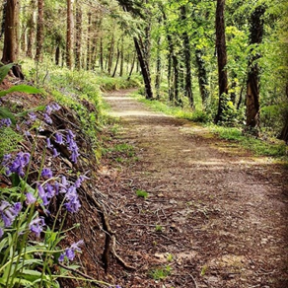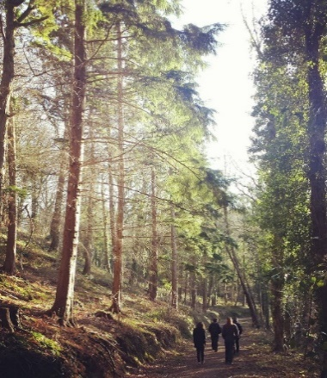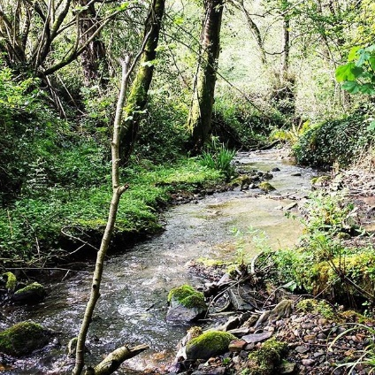

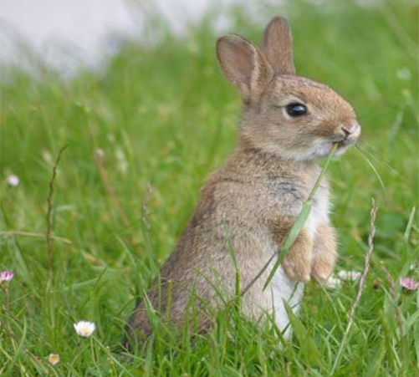

Introduction

As a university, we have a duty under the Environment (Wales) Act 2016 to maintain and enhance biodiversity across all of the University’s functions, and in so doing, promote the resilience of ecosystems. This duty (Section 6) replaces and enhances the previous duty, Natural Environment and Rural Communities Act 2006 (NERC Act).

Under the Environment (Wales) Act all public bodies in Wales are required to: -
- Maintain and enhance biodiversity when carrying out their responsibilities and in doing so promote the resilience of ecosystems.
- Demonstrate an ecosystem approach by applying the systems set out in the act.
- Prepare and publish a plan outlining how they intend to fulfil their duty.
- Publish a report every three years on the actions they have taken to meet this duty.
To achieve this the University is committed to working within the six objectives of the Nature Recovery Action Plan for Wales (NRAP12), which have been identified to contribute to reversing the decline of biodiversity in Wales. Working within these objectives will not only help the university become more sustainable but will also contribute towards seeking the best outcomes for the economic, environmental, social and cultural wellbeing of Wales as required by the Wales Future Generation Act.

The six objectives to maintain and enhance biodiversity are:

- Objective 1: Engage and support participation and understanding to embed biodiversity throughout decision making at all levels
- Objective 2: Safeguard species and habitats of principal importance and improve their management
- Objective 3: Increase the resilience of our natural environment by restoring degraded habitats and habitat creation
- Objective 4: Tackle key pressures on species and habitats
- Objective 5: Improve our evidence, understanding and monitoring
- Objective 6: Put in place a framework of governance and support for delivery.

Environmental Sustainability Strategy 2018-2025

The University, through its Environmental Sustainability Strategy 2018-2025 has committed to reducing the environmental impact of its operational activities and to make a positive contribution to the natural environment through the management of its estate and resources. The University is therefore committed to reducing the decline of biodiversity in order to enhance the health and wellbeing of all its’ stakeholders and that of the wider community. In order to achieve this, the University will undertake a programme to reverse the decline of biodiversity by making changes to the way it manages its’ estate.

The University’s Environmental Sustainability Strategy outlines its aim in relation to Biodiversity as being: -

To protect, preserve and enhance natural habitats, local wildlife and biological diversity on sites that the university owns or manages and promote its benefits for students, staff and the local community.

In order to achieve this, the University has committed to undertake the following actions:
- Undertake university wide biodiversity audits to monitor priority habitats and species and inform the development of appropriate management, maintenance and conservation plans
- Use the habitat resources appropriately and sensitively for Education in Sustainable Development
- Develop the use of sustainable land management practices where appropriate
- Promote awareness and appreciation of conservation and the richness of biodiversity on the University campuses and within the local and wider communities

The University has also set targets to achieve this by ensuring:

- Ecological reports are undertaken for all University sites by 2023
- Review the Biodiversity action plan annually and report progress against targets via various communication channels
- Three staff/student or community volunteering activities relating to biodiversity enhancement to take place per annum.

Natural Resources across Wrexham Glyndwr University

Wrexham Glyndwr University is situated across a number of sites. Its main campus is on the outskirts of Wrexham Town Centre and is in a predominately urban setting. There are three other campuses, Regent Street, which is an urban art facility, St Asaph which is a research and science centre in a semi-rural setting and Northop which is set in a hundred acres of meadow and ancient woodland.
The campus measures approx 15 hectares. The main habitats for the Plas Coch site in Wrexham comprises of buildings, trees, hedgerows and shrub/scrub vegetation. There has also been a recent inclusion of the Glyndwr science garden which has been planted with wild flora.
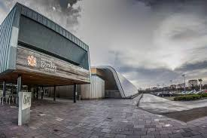
The site in St Asaph measures approx. 3.14 hectares and compromises of buildings and hard standing car park. Areas of planted hedgerow, scattered trees and shrubs surround the car parking area.

The Regent Street site measues 0.53 hectares and is mainly buildings, concrete paving and hard standing. The only vegetation is a small bed of shrubs, silver birch (Betula pendula) and lime (Tilia sp.)

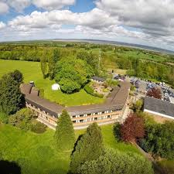
The Northop site measures approx 31 hectares and has a mixture of habitats and landscape features comprising of woodland, scrub, grassland and wetland. This site is the University’s main site for Biodiversity and its features are described in much more detail in Part 2 of the Biodiversity Plan, together with an evaluation of its conservation and biodiversity value with recommendations to maintain and enhance their interests for wildlife. Recording is executed throughout the year to assess species richness or any loss to biodiversity throughout the year.

Biodiversity in WGU

Wrexham Glyndwr University has a range of habitats and a variety of ecosystems- see diagram below.

There are therefore many things the university can do to make a positive contribution to biodiversity. Whatever the approach to engaging with biodiversity, it is important that the initiatives are appropriate for the environment the university campuses inhabit and the resources available. Central to the success of the Biodiversity Enhancement Plan is that the goals are achievable. This may mean a phased approach, starting with some of the activities which are less demanding in terms of resources and specialist expertise and gradually expanding the programme over a number of years. A successful plan is not simply a matter of making resources available; significant achievements can be made when there is a commitment to biodiversity at senior management level as well as individual champions at "ground level" to drive the strategy through the implementation phase and have involved stakeholders in the Biodiversity Plan process.

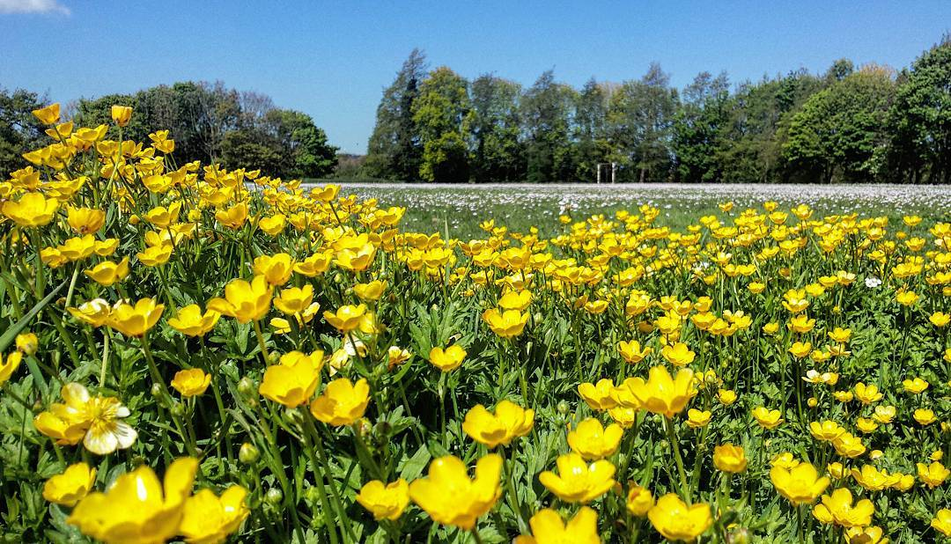

The plan contained within the appendix of this document will outline the actions the University will undertake to enhance its biodiversity. It will:

- Describe the natural resources we have.
- What WGU proposes to do to protect them.
- How we will enhance and improve them.
- Give a detailed report on the plan.

Monitoring & Communication

The Biodiversity Enhancement Plan and Annual Report will be compiled by Biodiversity Officers and Academics based on the Northop Campus with the guidance from members of the Sustainability Action Working Group (SAWG) and the Executive Director of Operations. Input from other departments and Faculties across the University will be sought as necessary.

Monitoring and Communication of the Plan will be directed through SAWG which includes representation from both Academic and Professional Service areas. Student representatives are also key partners at the Working Group.

The Executive Director of Operations chairs the Sustainability Action Working Group and has key responsibility for the oversight and implementation of the delivery plan and ensuring that the actions within the plan are addressed and progress monitored and communicated. This will include reporting quarterly to the Safety, Health and Environment (SHE) Committee, the Vice Chancellors Board and through to the HR Committee (a sub-committee of the Board of Governors)

The Plan will be published and available on the Wrexham Glyndwr University web pages.
- Financial
All cost to delivery this plan will be met from existing budgets.
- Legal
Failure to deliver the plan and implement recommendations will render the University in breach of its’ statutory duties.

Biodiversity Enhancement Plan 2018-2025 (Framework).
Nature Recovery Action Plan Objective 1 | Engage and support participation and understanding to embed biodiversity throughout decision making at all levels

Code | Aim | Action | Lead | Key Depts | Performance measure
1.1 | Ensure biodiversity integration with SAWG | Biodiversity and sustainability to be taken into account during the decision making process. Ensure links with partners Cofnod, NWWT. | Estates | Estates and SAWG | Legislation and policy included in documentation where applicable (Executive director panel)
1.2 | Implement the new biodiversity and ecosystems resilience duty | Identify departments key responsibilities to creating opportunities and amending actions in the duty plan  Produce a biodiversity and ecosystems resilience duty delivery plan | Estates | Estates and SAWG | SAWG to identify key departments role for actions and monitor  Estates to update and amend biodiversity and ecosystems resilience plan – on going
1.3 | Legislative and policy requirements are reflected in reports | Identify and assess university plans and proposals for biodiversity impact, providing recommendations  Inclusion of the biodiversity and sustainability duties within committee reports | Estates and SAWG  SAWG and executive committee | Estates and SAWG | On- going access by estates to amend report where necessary according to change in legislation or circumstance  Completed report assessed by Executive Committee
1.4 | Increasing awareness of plan | Links with P.R and marketing, Cofnod, NGO’s  Awareness and education through the use of effective P.R, marketing, events, ensuring that the policies and report is available to students studying biological sciences to become an integral part of the ownership of the plan | Estates, SAWG  Academics | Estates | SAWG to promote and effect communication between departments  SAWG to promote and effect communication between departments
 |  | Link to Green champion, sustainability and environmental activities via P.R, marketing and student societies | Estates, SAWG  P.R/ Marketing | Estates and SAWG | Estates and SAWG meetings
 |  | Promote volunteering on sites to enhance work and reduce the workload for Estates, to enhance student knowledge and experience and well being | Estates, SAWG, Academic | Estates, SAWG, Academic | SAWG/ Academic; communication

Nature Recovery Action Plan Objective 2 | Safeguard species and habitats of principle importance and improve their management

Code | Aim | Action | Lead | Key Depts. | Performance measure
2.1 | Confirmation of environmental legislation within documentation | Include environmental legislation in documentation | Estates | Estates/ Executive Committee | Assessment of documentation by Estates and Executive committee
2.2 | Provide evidence to ensure that species and habitats are safeguarded by following the plan. | Ensure relationships with government and NGO continue levels of communication with COFNOD (LERC) | Estates | Estates | Accessibility to reports and partners
2.3 | Assess resilience of ecosystems against environmental changes (e.g. effects of climate change – seasonality differences between different species relationships within a given ecosystem. | Monitoring of records and assessments of trends. | Estates | Estates | Results of trends will show major changes in species presence although not abundance
2.4 | 2.4.1 Create management strategies to cope with environmental change | Adapt management within Biodiversity and Ecosystem Resilience plan according to nature recovery action plan. Assess for costs | Estates/ SAWG | Estates/ SAWG | Re-assessment of species, ecosystem or habitat and monitoring to ensure resilience.
2.5 | Ensure links to outlying habitats or species populations are connected via wildlife corridors; hedgerow etc. using the plan | Record and assess species geographic position | Estates | Estates | Examination of data to assess trends and movement of species or habitat degradation

Nature Recovery Action Plan Objective 3 | Increase the resilience of our natural environment by restoring degraded habitats and habitat creation

Code | Aim | Action | Lead | Key Depts. | Performance measure
3.1 | Increase the diversity of habitats for pollinators | Arrange for varying lengths of grassland to be cut at intermittent periods allowing margins for recovery | Estates | Estates | Increase in diversity proven through higher record presence and abundance
3.2 | Restore waterways and Ponds | Organise volunteer work party for pond clearance to increase resilience | Estates | Estates | Monitoring. Increased diversity of flora and fauna in worked areas as proven by last pond clearance 2018 and records taken from the Bio blitz in 2019
3.3 | Thinning of woodland or coppicing of site promotes growth and promotes biodiversity | Tree surveys on key sites to assess what we have. Coppicing and clearance; see plan | Estates | Estates | Monitoring of growth and impact on cleared areas
3.4 | Schedule 8 plants - protected | Area containing schedule 8 plants to be sectioned off to allow for proper seeding | Estates | Estates | Perpetuation and recovery levels recorded to ensure management strategy is working

Nature Recovery Action Plan Objective 4 | Tackle key pressures (Climate change/Invasive non-native species/Habitat loss) on species and habitats

Code | Aim | Action | Lead | Key Depts. | Performance measure
4.1 | Climate Change | Assess co-dependency within ecosystems to account for seasonality. E.g. flowers appearing late so that pollinators have no food source.  Be aware of potential periods of drought or prolonged rain – counter with alternate food supplies  Carbon emission reduction  Enhancement of biodiversity /renewable energy | SAWG  SAWG  Estates / SAWG  SAWG | SAWG  SAWG  Estates  SAWG | Monitor balance of abundance to assess the needs of the deprived specie and report to SAWG  Monitor populations record and report
4.2 | Eradication of Invasive Species | Monitor for invasive species American Skunk Cabbage around pond and check for occurrences of Himalayan Balsam on banks of river | Estates and INNS officer | Estates | Monitor and record for zero presence
4.3 | Assess and reduce stress on habitats and priority species | Ensure habitats for priority species (section 7) are maintained according to the plan | Estates | Estates | Monitoring for presence and abundance to check declines

Nature Recovery Action Plan Objective 5 | Improve our evidence, understanding and monitoring

Code | Aim | Action | Lead | Key Depts. | Performance measure
5.1 | Budgeted time to provide more evidence for decision making | Better use of evidence to manage the sites | Estates / Cofnod (Lerc) /  Executive Committee | Estates | Better reporting and able to provide a measured response to the biodiversity and resilience issues with the sites and ecosystems
5.2 | Better reporting of evidence to support plan and make fluid adjustments to the plan through analysis of data and reflection of impact | More time set aside to create and analyse evidence to benefit the management of flora and faunae | Estates |  | Quicker response to ecological issues
5.3 | More studies using the data from monitoring and recording using the data provided by Cofnod (Lerc)  to assess environmental and biological impact.  Stability of ecosystems | Create analysis format for impact assessment | Cofnod /Estates  Executive committee |  | Thriving and balanced ecosystems. Equal or increased biodiversity figures
5.4 | Increased understanding of existing ecosystems | Encourage more students to record Flora and fauna  More public events. Bioblitz or fun days to raise awareness of the need to record and monitor | Estates/ academic  Estates/ SAWG/Executive committee/ P.R and marketing |  | Increase in abundance figures and dates to monitor seasonality  Greater awareness, Higher recording and monitoring figures, abundancy figures rather than just presence

Nature Recovery Action Plan Objective 6 | Put in place a framework of governance and support for delivery

Code | Aim | Action | Lead | Key Depts.
6.1 | Compliance to the environmental laws and policies | Assess time/and priorities of existing staff | Estates / Executive Committee | Estates / Executive Committee | Staff and resource availability
6.2 | Increased revenue to support biodiversity (Plan) | Look at grants for biodiversity projects | Estates / SAWG/Executive Committee/ Cofnod (Lerc) | Estates / SAWG/Executive Committee/ Cofnod (Lerc)
6.3 | Use of the plan as a Framework of support | Publish and ensure that people are aware of the plan, integrate groups and ownership | Estates / P.R/Marketing/ SAWG/Executive Committee/ Cofnod (Lerc) | Estates / P.R/Marketing/ SAWG/Executive Committee/ Cofnod (Lerc) | Greater communication between departments and organisations
6.4 | Incorporation of governance and support within the framework of the SAWG committee | Link to SAWG policies | Estates / SAWG | Estates / SAWG

