

| **CONTROL HEADER** | | | |
| --- | --- | --- | --- |
| **Department** | Estates | | |
| **Author** | Mike Hamer | | |
| **Authorised By:** | Executive Director of Operations | | |
| **Implemented By:** | Estates | | |
| **Policy Reference:** | PREST2122026 | | |
| **Policies Replaced:** | NA | | |
| **Version No:** | 1 | **Approved Committee:** | N/A |
| **Date Approved:** | 24/07/22 | **Minute no:** | N/A |
| **Status:** | Approved | **Implementation Date:** | July 22 |
| **Period of Approval:** | 3 Years | **Review Date:** | July 25 |

|  |  |
| --- | --- |
| I have carried out an equality impact assessment screening to help safeguard against discrimination and promote equality. |  |
| I have considered the impact of the Policy/Strategy/Procedure *(delete as appropriate)*  on the Welsh language and Welsh language provision within the University. | ✓ |

# **Electric Vehicle (EV) Charging Procedure**

1. **Introduction**

The University’s Electric Vehicle Charging Procedure aims to give clarity on charging locations and arrangements. It also aims to encourage more University car commuters to purchase or use their EV’s for commuting or travel to the University, with the assurance that charging points will be available.

More and more vehicle manufacturers are producing EV’s and hybrid cars powered by electric motors and traditional combustion engines within their vehicle ranges. Charging points are being introduced in increasing numbers and locations including motorway service areas, public attractions, and largely Civic infrastructure. Travel by EV’s is becoming more common on our roads.

Welsh Government has set out its legal commitment to achieve net zero emissions by 2050. In 2021 interim targets have also been set for 2030, 2040 and 2050, against carbon budgets (2021-25 and 2025- 2030). The transport sector, as one of the largest contributors to greenhouse gas emissions, has a significant part to play in achieving net zero.

The University owns and operates its own fleet of electric vehicles (EV). To ensure its vehicles are available for use, WGU has installed several charging points across its campuses. University vehicles are usually charged overnight, so they are fully charged ready for use the following day. This will also ensure that the electric charging bays are then available for Students, Staff, and visitors with fully electric vehicles to use during normal business hours.

1. **Background**

Welsh Government published “Prosperity for All: A Low Carbon Wales” which sets out how Wales aims to meet its carbon targets. This includes proposals to address the adoption of electric vehicles and the required charging infrastructure. The policies aim to:

* Increase the uptake of electric vehicles (including battery electric vehicles, hybrids and plug-in hybrid) and promote active travel.
* Reduce the carbon footprint of buses, taxis and private hire vehicle fleets to zero emissions by 2028.
* Explore the possibility for all new cars and light goods vehicles in the public sector fleet in Wales to be ultra-low emission by 2025. Where practicably possible, all new heavy goods vehicles are ultra-low emission by 2030.
* Invest in public charging infrastructure.

To support the implementation and integration of the Welsh Government targets discussed above, the University utilised grant funding to install 14 charge points and purchase seven full electric vehicles to refresh it fleet.

1. **Vehicle Charging Arrangements**

This operating procedure covers the charging of university owned Vehicles and the use of the EV charge stations for Private use by Staff, Student and Visitors.

The charging of university owned vehicles will be via a programmed key fob.

TheUniversity’s EV charging partner until 2024 will be **Vend Electric.** Information on the Vend Electric services platforms can be found at <https://vendelectric.com/>

Staff, Student & Visitor charging will be facilitated via the Vend Electric mobile App where a private account is set up with direct payment to Vend Electric.

The University will receive a monthly remittance and income from Vend Electric for costs resulting from private charging.

The cost to charge a privately owned vehicle will be charged at **10p per kWh above the University flat purchase rate**. This actual rate at the point of charge is made clear to users prior via the Vend Electric App.

There is **Maximum Stay of 180 minutes**. If this time is exceeded, an overstay charge of £10 will be applied to the user’s account.

1. **General Arrangements**

Only EV’s and electric scooters should occupy charging bays. Use of charging points should be prioritised for full EV models. Hybrid charging will be permitted where low demand can be demonstrated for EV outlets.

Parking in an electric vehicle charging bay is only permissible for the duration of the charge. Vehicles must be moved to another location when the charge is complete. Any staff, student or visitor who use these spaces for general parking will be in breach of the University’s car park regulations and risk the imposition of an infringement notice.

Overnight use of charging points is by prior arrangement with the Estates Administration Team. Where required, University fleet vehicles will be charged overnight to manage high daytime demand.

The location of the Charging points/bays are as follows: -

* 4No. Mold Road Car Park
* 6No. Students Union Car Park
* 4 No. Catrin Finch Centre
* 1no. Northop Campus – near Corbishley Hall.
* 1No St Asaph Campus (being installed summer 22)

**Note -** All locations are Type 2 32Amp (7.2kW) chargers

User instructions ensuring safe use are provided at each charging point.

The location of the car parks where EV points are provided are detailed on the University’s Campus Map. Should a decision be taken to make the chargers publicly accessible they would be added to the Vend Electric advertised network.

The Estates Security team will monitor and ensure that drivers of EV’s use the facility for the appropriate charging time and in line with this procedure. The University reserves the right to issue an infringement notice on vehicles found to be parked in EV charging bays in breach of this procedure.

1. **General Operating Instructions**

**Parking**

1. Only Park at a charge point if you intend to charge your electric vehicle.
2. Parking in an electric vehicle charging bay is only permissible for the duration of the charge. Vehicles must be moved to another location when the charge is complete.
3. Any staff who use these spaces for general parking will be in breach of the University car parking regulations and risk the imposition of an infringement notice

**Plugging In**

1. Only plug into the charge point if you genuinely need a charge.
2. Please do not remove another person’s cable from a charge point or use someone else’s cable without permission.
3. The charge points listed are not available for public use

**Starting a Charging Session - University Vehicles**

1. Connect the University vehicle to the EV charger
2. Present the Key Fob to the RIFD reader on the charger as shown below
3. The charge cable will make a ‘lock’ sound when in place
4. The charger led circle will turn green to confirm connection.
5. Please ensure your charging session has started successfully before leaving your vehicle.

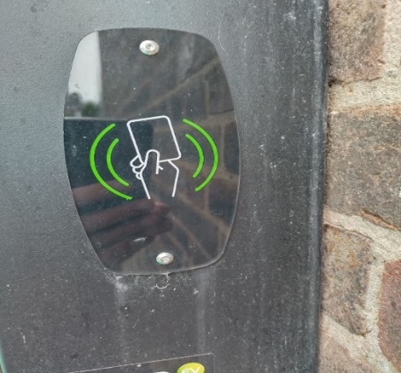

**Starting a Charging Session- Private Vehicles**

1. All University EV charge points have operating instruction as shown below.

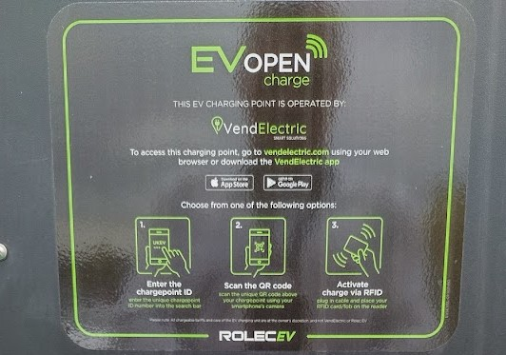

1. Download the App, set up a personal account
2. Connect to the charger ensuring that the charging cable are not causing a hazard to others
3. Place mobile device next to RFID reader
4. The charge cable will make a ‘lock’ sound when in place
5. The charger led circle will turn green to confirm connection.

**Whilst Charging**

1. It is considered polite to return to your vehicle as soon as possible once your vehicle has charged to make the charge point available to others; however, some users may not be able to return immediately so please be patient.

**Ending a Session**

1. Please make sure that you end your charging session with the access method you used to start our charge before leaving the charge point.
2. Disconnect charge cabling and careful store back in the vehicle.