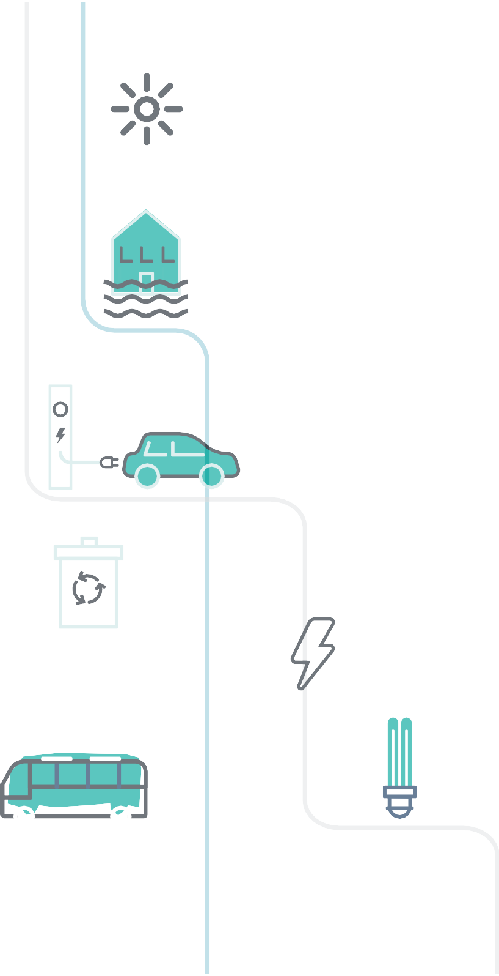

PATHWAY TO CARBON NEUTRAL BY 2030

A route map for decarbonisation across Wrexham University

V2 30/06/23

Purpose of the route map
This document provides a strategic overview of the key priority areas for action and milestones needed for Wrexham University is contributing to support Welsh Government achieve their aim ofa carbon neutral public sector by 2030.

- It does not set out the ‘how’, ‘who’ or the actions needed to achieve the milestones, it is a strategic framework to help assess what is in place and what is needed to get to where we collectively need to be, and to monitor progress over time.

- The focus is the University’s own footprint, though acknowledging there is an important wider influence and leadership role.

- The framework will support the development of our low carbon transition and delivery plan and will prioritise 4 key areas.

- This supports the collective responsibility being placed on all Welsh public sector organisations to achieve Welsh Governments carbon reduction ambition.

Vision
By 2030, choosing zero carbon will be routine, culturally embedded, and self-regulating across Wrexham University.

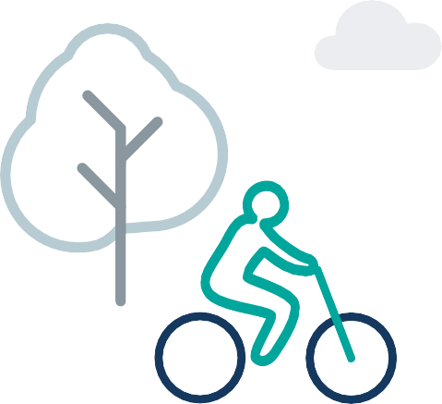

The Journey to carbon neutral

Moving up a gear | Well on our way | Achieving our goal
2022‒2023 | 2023‒2026 | 2026‒2030
Where understanding the context and what needs to be done is vital, and where action needs to accelerate | Where there is an expectation that low carbon is becoming the norm and we are on the way to a carbon neutral University. | Where choosing zero carbon has become routine, culturally embedded, and self-regulating

A Thematic Approach

Behaviours |  | Standards |  | Innovation
University Community | Individual | System Governance | Use of resources | Model of service delivery | Technology
A compassionate and supportive society living in a high-quality environment with reduced inequalities. | Values are redefined to encompass well-being linked to an acceptance of finite resources. | Institutional well-being will drive policy which supports individuals and the University Community to behave in a sustainable, fair and health-conscious way. | We live with the resources that the environment can support | Models of zero carbon service delivery where the university community have control over their well-being. | Technology is an enabler of positive societal and environmental change.

The Route map: a strategic framework for change

 | Behaviours |  | Standards |  | Innovation
 | University Community | Individual | Governance | Use of Resources | Models of Service Delivery | Technology
 | We engage with the climate change debate. The University explains its case for taking sustainability seriously and considers how it can impact the wider society | Staff and students understand what they can do. They know they should act. They know they can make a difference. | Agree on responsibilities, mechanisms and measures including legislation, regulation, and public reporting of progress. | Research how to use all types of resources better to enhance health and minimise waste. Identify, prioritise, and address gaps in knowledge. | Explore sustainable models. Increase investment to prevent disadvantage and improve well-being. Optimise benefit from nature. | Adopt and invest in sustainable technologies. Welcome innovation and support sustainable development research projects
Moving up a gear
2022 - 2023
 | We integrate action on climate change into every programme and it becomes part of our civic mission. | Staff and students expect to be able to make choices based on sustainability and well-being criteria when considering services and products | Account for climate change future impacts in decision-making processes. Life cycle costing is the norm in university procurement decisions. | Model business decisions so entire resource impact is accounted for. All resources need to include full life cycle carbon costings. | Collaborate with partners to prevent social inequalities, promote well-being, and develop sustainable joint project plans. | Enable and support technology to allow the empowerment, equality and well-being of individuals.
Well on our way
2023-2026
 | We embed value over cost. By doing so, WGU understands, accepts and expects that sustainability and climate action is integral to its business | Staff and students demand zero tolerance of unsustainable behaviour as it is socially unacceptable | Self-regulate and feedback processes across the university. Sustainability is part of life. | Value all resources including people’s time and the natural environment. Account and profile all resources for a no waste approach. | Tailor university-centred, low carbon services. The university works with partners to reduce inequalities & improve well-being | Require and expect low carbon technologies to be incorporated in all aspects of the university estate.
Achieving our goal
2026-2030+

Priority areas for action: emissions footprint

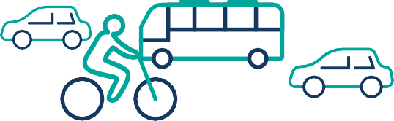
Buildings Mobility and transport

Procurement Land use

The journey to carbon neutral:

Buildings

The climate impact of our built estate is well understood.
Our construction programmes include mandatory carbon neutral objectives.
A low carbon transition and delivery plan is developed for hard to decarbonise buildings.
Scoping for low carbon heat projects is underway and progress is being made to become more energy and water efficient incorporating renewable opportunities.

Moving up a gear
2022 - 2023
Firm proposals and business cases are in place for hard to decarbonise building types.
All remaining existing buildings will be highly energy efficient OR scheduled for replacement
A renewable heat strategy will be rolled out.
Well on our way
2023-2026
All new University buildings are built to carbon neutral standards.
All University buildings are supplied with low carbon heat by 2030 and generate their own electricity where feasible.
The focus is no longer on buildings but healthy environments to live, work and visit.
Achieving our goal
2026-2030+

The journey to carbon neutral:

Mobility and transport

We will continue to work flexibly and make greater use of active travel arrangements.
We will understand the nature and use of our fleet, future patterns of usage and a pathway for an ultra-low emission transformation.
We will accelerate the roll-out of EV charging infrastructure and our staff will be offered the opportunity to test ultra-low emission vehicles.
We commit to fleet transformation plans and there is a considerable upscaling of ultra-low emission vehicles uptake.
Moving up a gear
2022 - 2023
Continued flexible working, use of hubs and shared facilities, active travel and greater use of public transport significantly reduces car commutes and business travel in our working lives post-Covid pandemic.
All new cars and light goods vehicles in the university fleet are ultra-low emissions by 2025.
In collaboration with Wrexham and Flintshire local authorities, we will commit to healthier and more sustainable forms of transport, by publicly signing a Healthy Travel Charter.
Well on our way
2023-2026
Student-centred models of service delivery reduces the need for travel by staff, students and other service users.
Commuting and business travel takes place using Wales’s integrated public transport system where possible. Staff and students are actively encouraged to walk or opt for low carbon forms of transport to get to their places of work or study.
Achieving our goal
2026-2030+

The journey to carbon neutral: Procurement

We gain a good understanding of our emissions from procured goods and services, emissions profile, and supplier base.
We will Identify our category of spend areas with high / medium CO2e and explore how our current contracts can be used to act on CO2e reduction
We will review and revise our procurement policies and procedures to promote the reduction of carbon throughout the procurement lifecycle.

Moving up a gear
2022 - 2023
Suppliers are sent a strong signal regarding future low carbon requirements
All purchasing activities will have robust carbon phase built in at the earliest stage and throughout.
We will be requiring all bidders to submit a Carbon Reduction Plan on relevant high value tenders to ensure potential suppliers are focused on CO2e reduction.
Well on our way
2023-2026
The University has nurtured a productive, net zero carbon supply chain
Suppliers are incentivised through proportionate evaluation criteria to proactively seek further opportunities to reduce climate impacts.
Staff are empowered to challenge the status quo – request zero carbon alternatives is routine and use of alternatives business models are fully supported.
Achieving our goal
2026-2030+

The journey to carbon neutral:

Land use

Develop an understanding of land assets held by the University and their natural capital.
Determine the sequestration potential of land under university ownership and set out an agreed level of expectation and ambition.
We will connect people with nature by using university land to deliver outdoor environmental education so that they can appreciate the wider natural world and encourage them to have a responsibility for nature and wildlife conservation.
Moving up a gear
2022 - 2023
Review allocation and transformation of land to encourage and stimulate innovative approaches in the horticulture/food security sector, combining technical support and collaborative opportunities to accelerate the transition towards a low carbon economy.
Review land allocations and implement the biodiversity action plan which will encourage and connect existing habitats, woodland and natural environments to protect biodiversity and natural capital.
Well on our way
2023-2026
Initiatives to ensure communities are connected to green space have matured, and it is routine to integrate beneficial use of natural resources, green technologies and environmental sustainability into our educational programmes and activities.

The Northop Campus is a recognised National Welsh Institution which focuses on the 'One Welfare' concept, providing a living lab which provides the link between animal welfare, human wellbeing, biodiversity and the environment. It builds upon and complements the development of the 'One World, One Health' concept to achieve fully comprehensive approaches in support of global sustainable development.
Achieving our goal
2026-2030+

Supporting the journey to carbon neutral zero: Governance and energy planning

Our energy activities are aligned to the priorities of the regional energy strategies, managed by cross sector governance arrangements. We support local area energy plans which identify the changes needed to the local energy system, to decarbonise heat and local transport and realise opportunities for local renewable energy production.
The university baselines emissions and creates a low carbon transition plan.
Moving up a gear
2022 - 2023
We deliver the first phase of our low carbon energy plans, which identify energy interventions to meet our power, heat and transport needs and how they can contribute to making the university a place that people want to live and work.
Renewable development is now part of a wider energy and decarbonisation strategy.
The university is delivering its first tranche of emissions reduction based on the 2022 emissions baseline.
Well on our way
2023-2026
The university is now delivering a range of projects across heat, power and transport to become carbon neutral. These projects are delivered both independently and in partnership, but all are working to a single vision and plan for the energy system.
Achieving our goal
2026-2030+

Working Together to achieve carbon neutral

Our aim as a Civic University is to be useful, and to innovate, co-create, test and deliver new approaches to key challenges. In this context, we believe that the University has a wider role in shaping our society-wide low carbon transition. By working together with partners and communities, we must challenge ourselves and each other to use all the levers available to us and work together in partnerships to affect change – this route map provides a framework for that change and we are committed to undertaking the following:

- Support local businesses, public services, the voluntary sector, and government to avert a climate and biodiversity crisis by prioritising the reduction of inequality and help end social inequality across North Wales by 2030.

- Support innovative exploration and active intervention for positive change through co-produced critical inquiry, applied research and impact evaluation.

- To be an advocate for climate science, discussing, educating, and providing understanding of the local and global impact of climate change wherever possible.

- To work with business and industry in leading on Climate Change upskilling and training to ensure we have a pipeline of talent needed to address our climate emergency
.

